**Assignments 1 ADTA 5750_NLP**

**Yog Chaudhary**

**11727095**

**ADTA 5750 Applied Natural Language Processing**

**Professor: Dr. Thuan L Nguyen**

**University of North Texas Sep 11, 2024**

3. **PART I: Select an Operating System (5 Points)**

I will be using Windows as an OS for this course, and good knowledge of drive, directions and folders, files, the ownership status of these components, and administrative privileges. I can create new folders, access existing ones along with their actual contents, and create and save files within these folders. Download software applications, store them in specific folders, and install these applications in real, physical directories. Additionally, I can troubleshoot issues using various resources, such as online research, vendor support, and public technical forums. Therefore, I can use Windows effectively for cloud-based deep-learning tasks. Windows offers a user-friendly interface for all these actions, making it convenient for this course.

**4. PART II: Set Up Deep Learning Virtual Machine (VM) in GCP (20 Points)**

* **Click on open GCP**
* **Click on the free Trail**
* **Enable computing engine.**

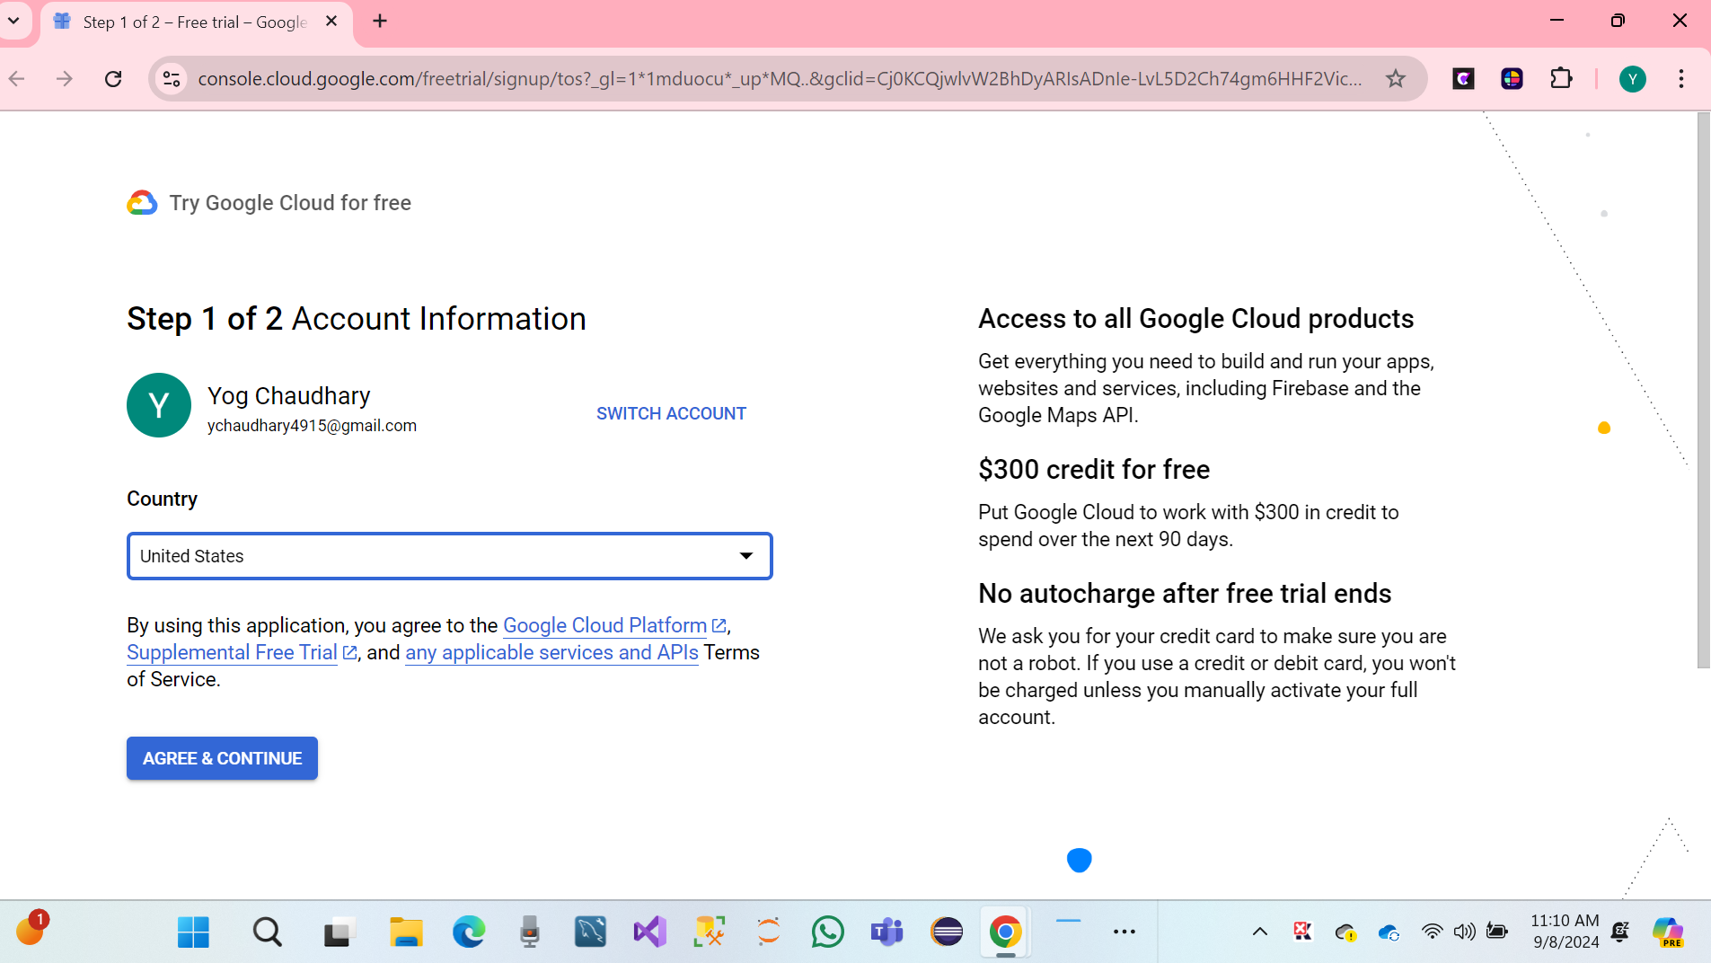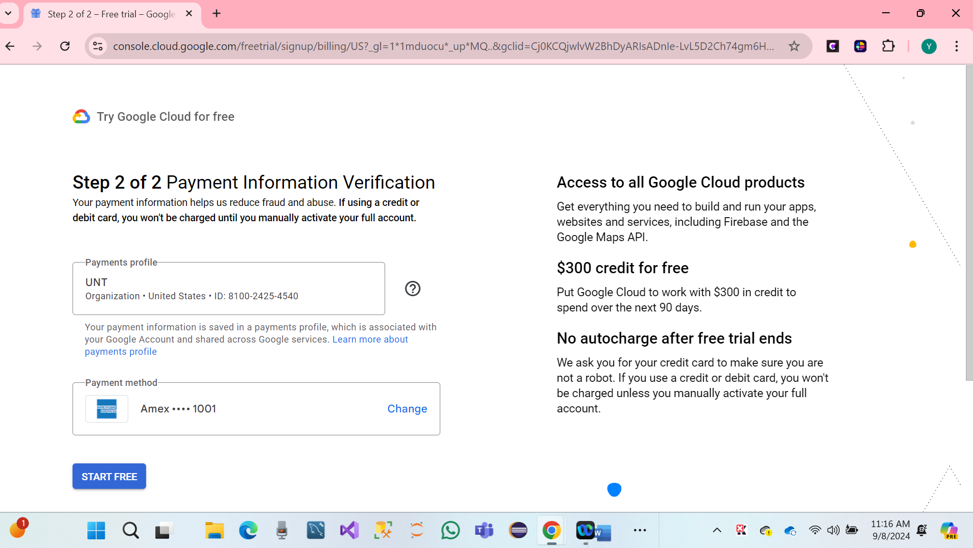

* Click on Activate and continue.

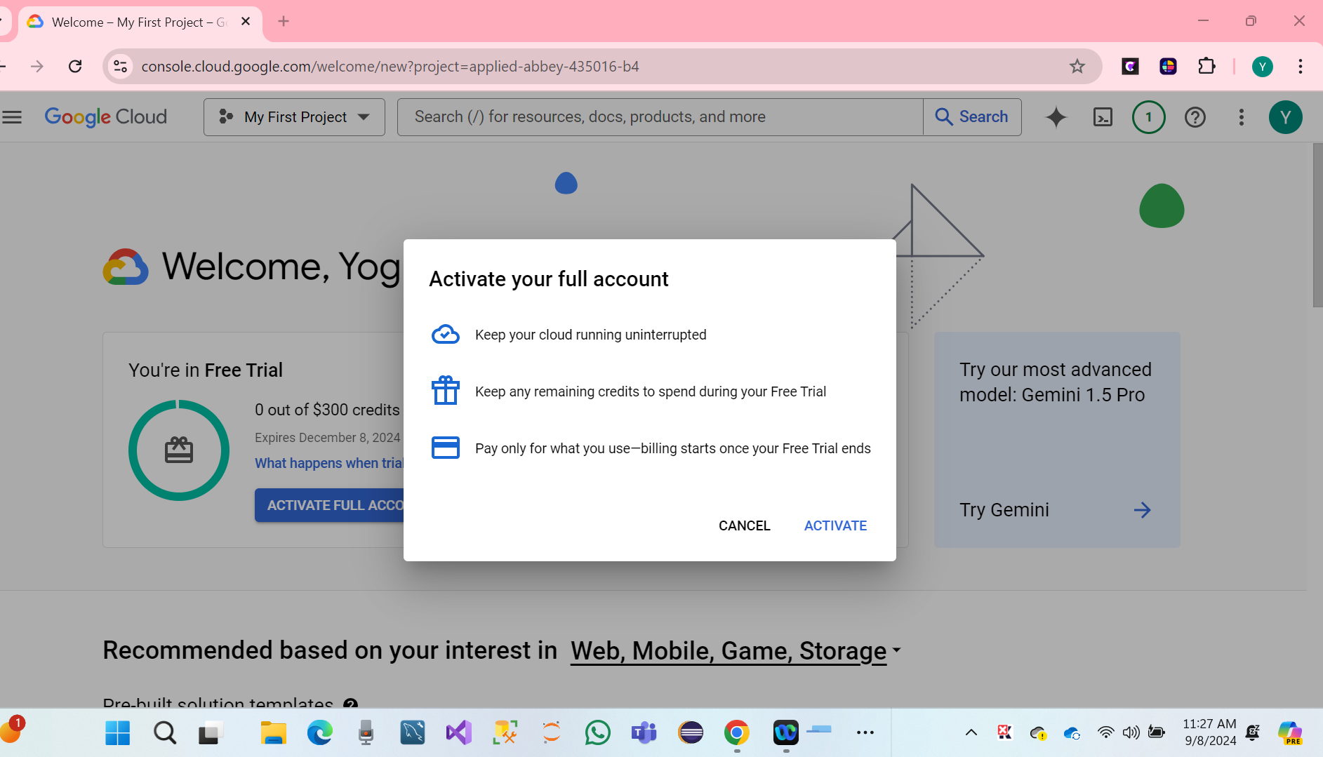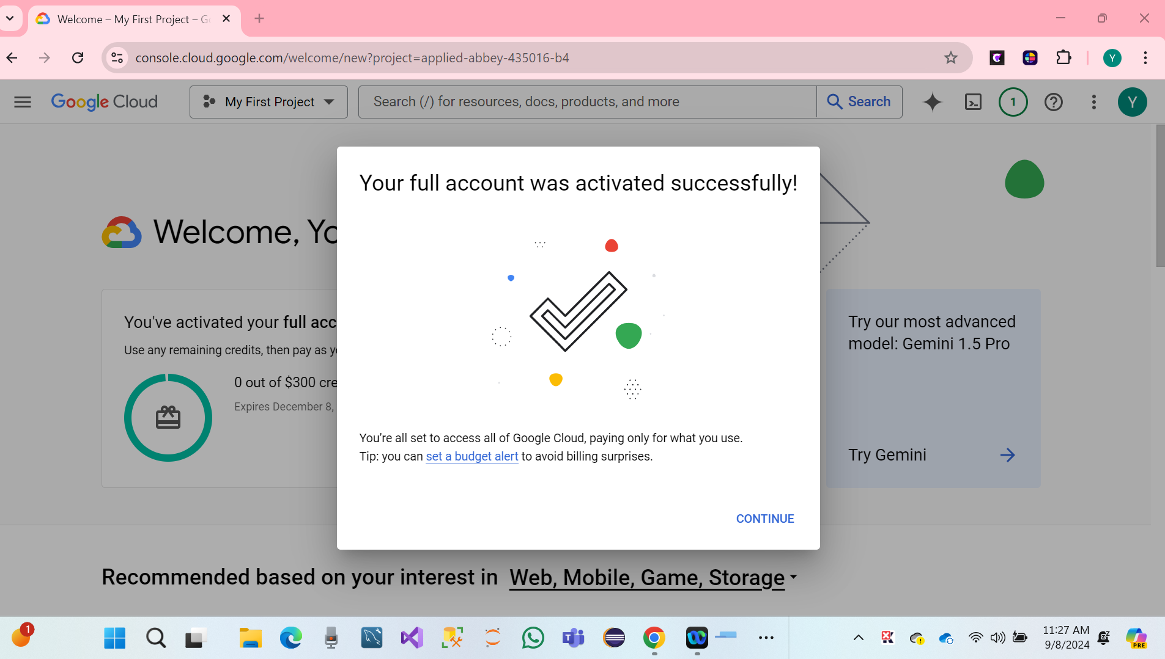

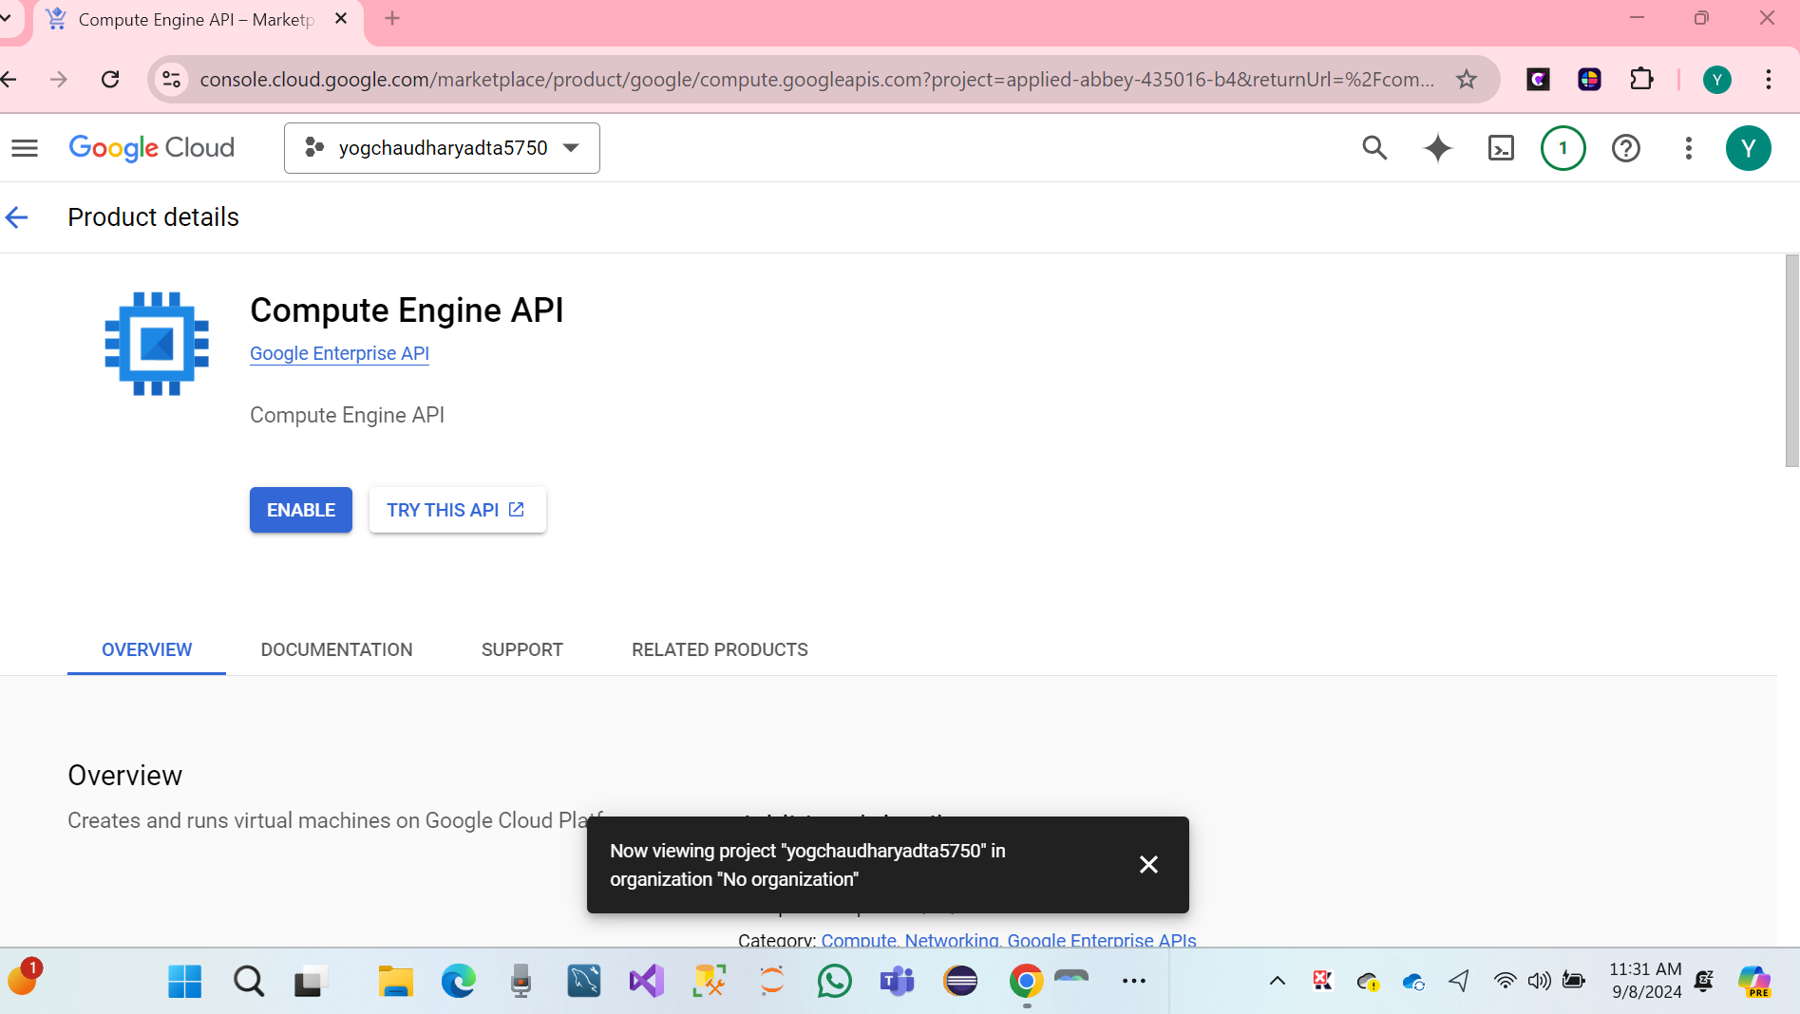

* Click on Enable computer engine.

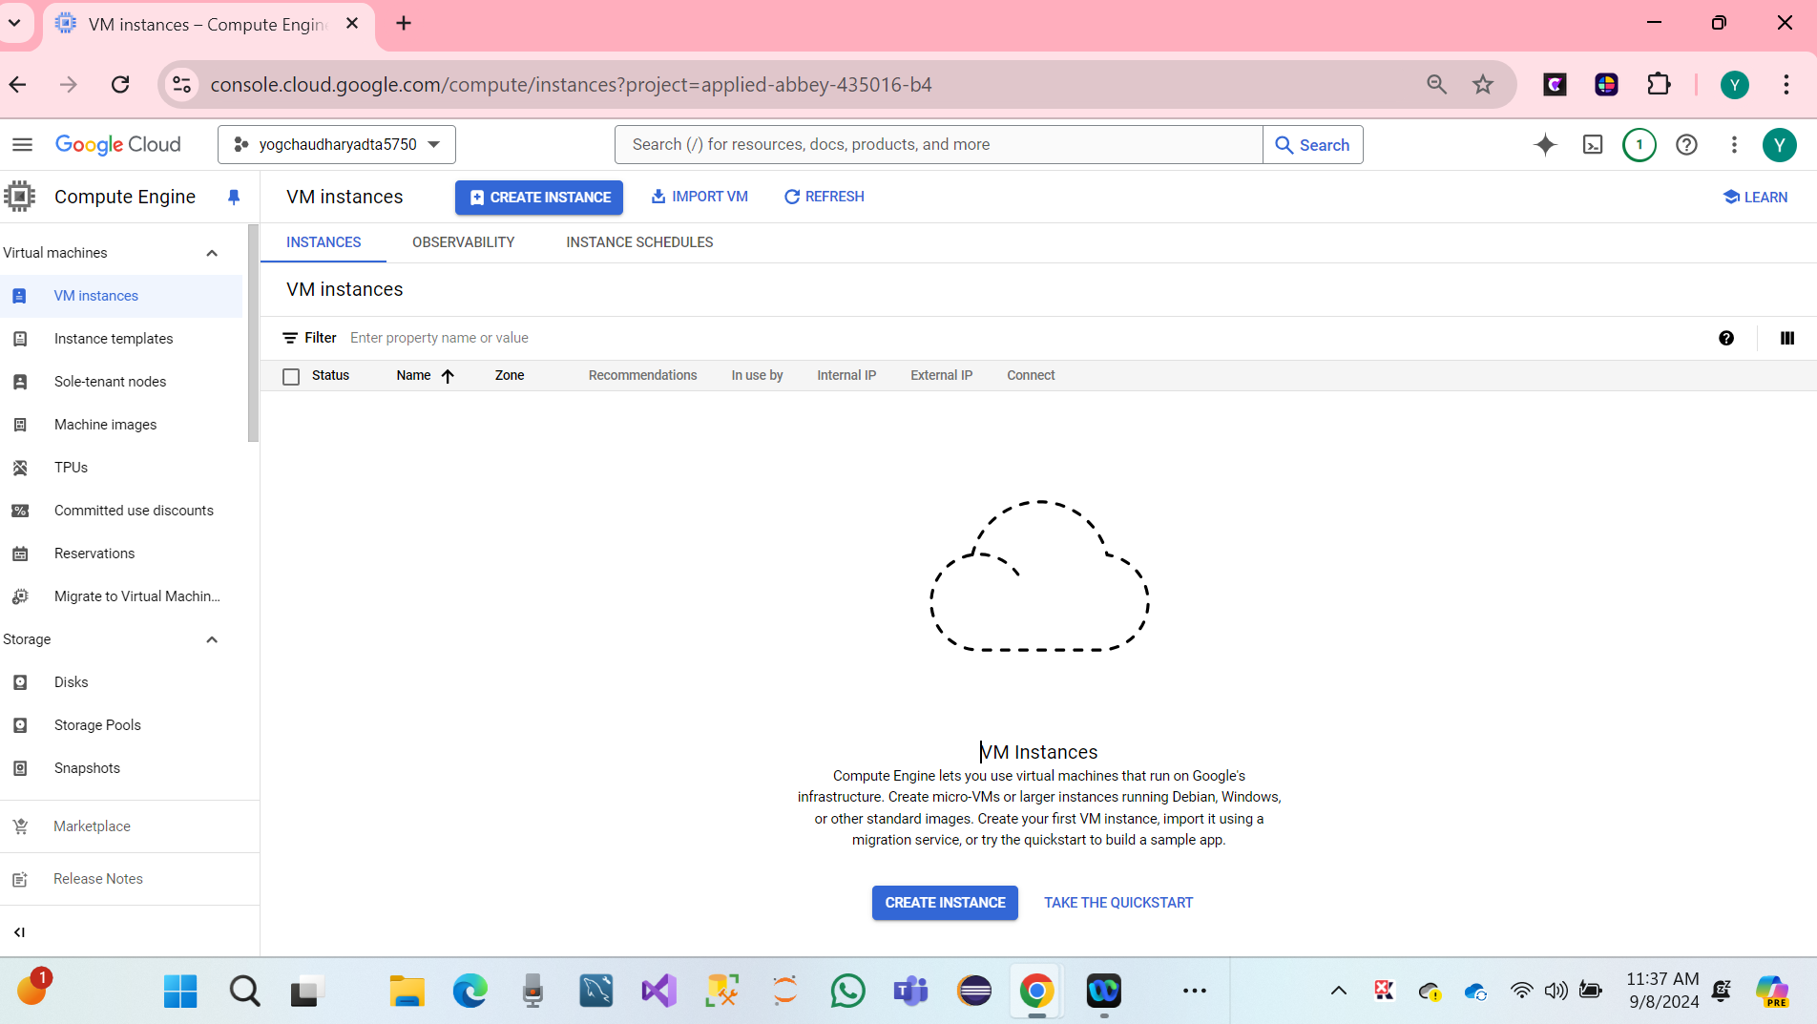

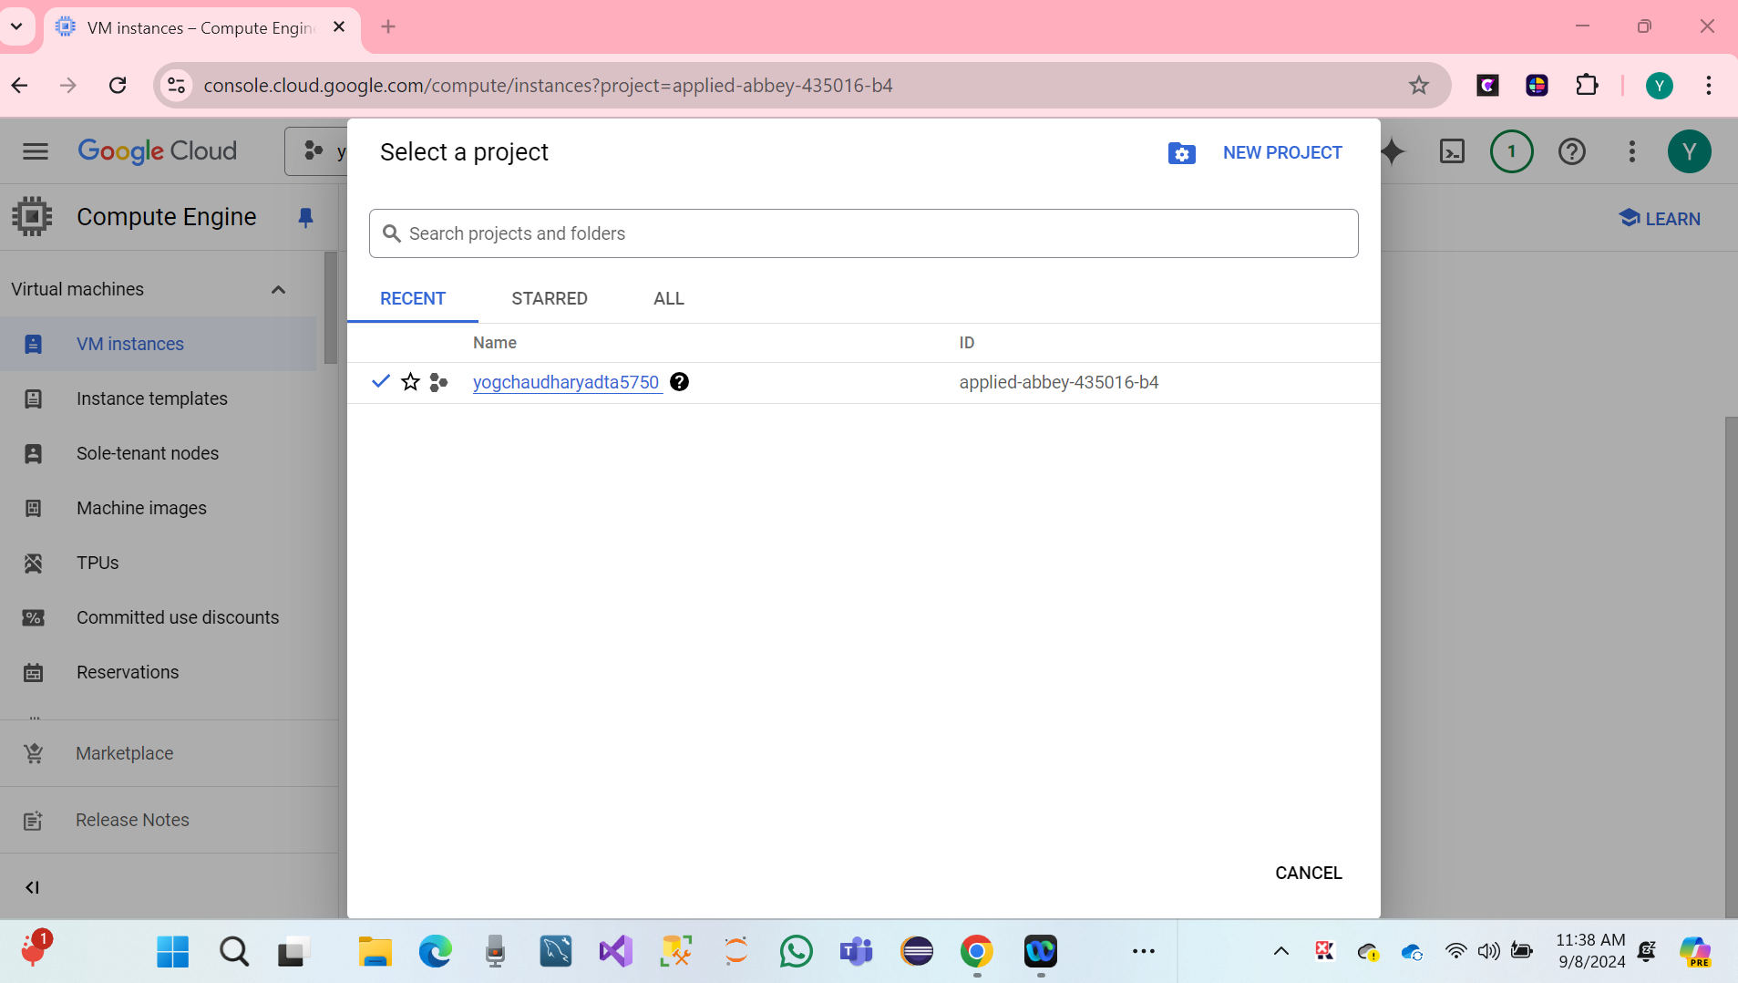

We have created **VM Instances**.

* Click on the search bar and click on cloud shell
* Click on Continue.
* Create Deep Learning VM Using GCP Deep Learning Image.
* Cloud Deep Learning VM Image.

**Click on link:** [**https://cloud.google.com/deep-learning-vm/**](https://cloud.google.com/deep-learning-vm/)

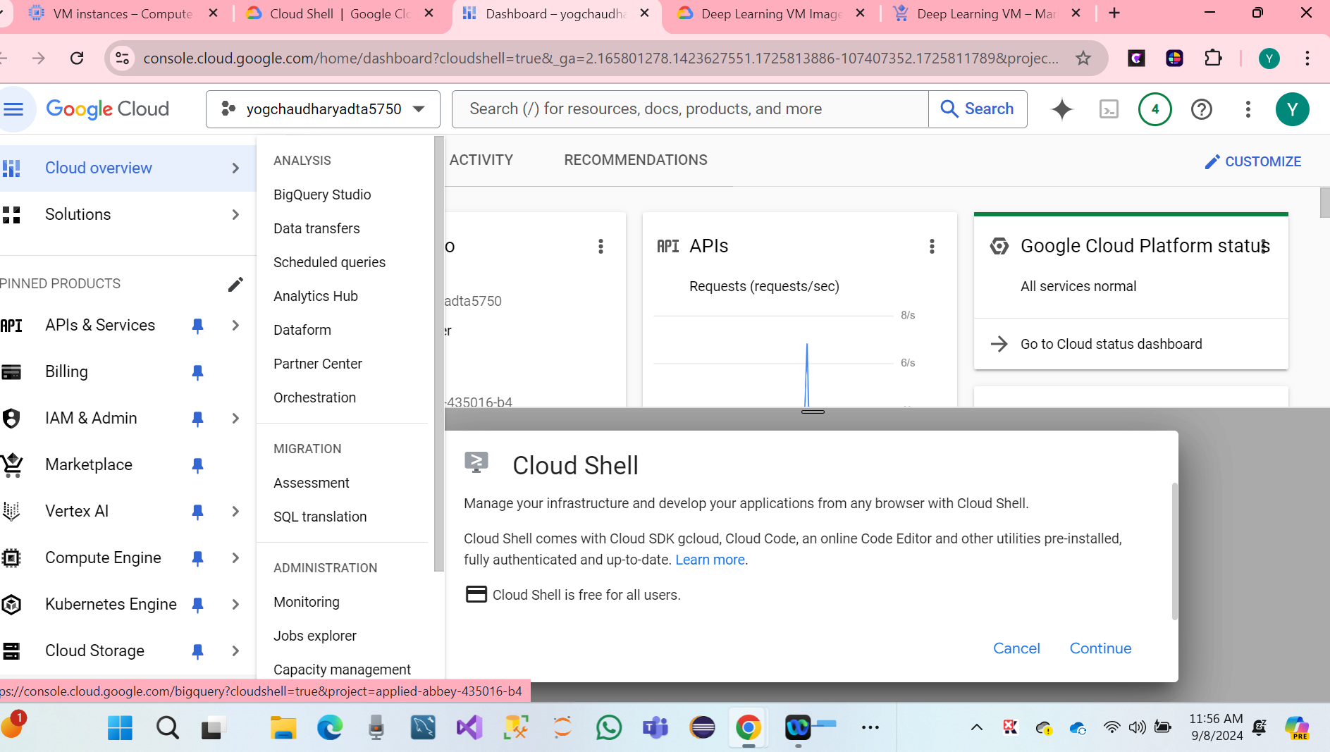

* Click on cloud shell to continue.

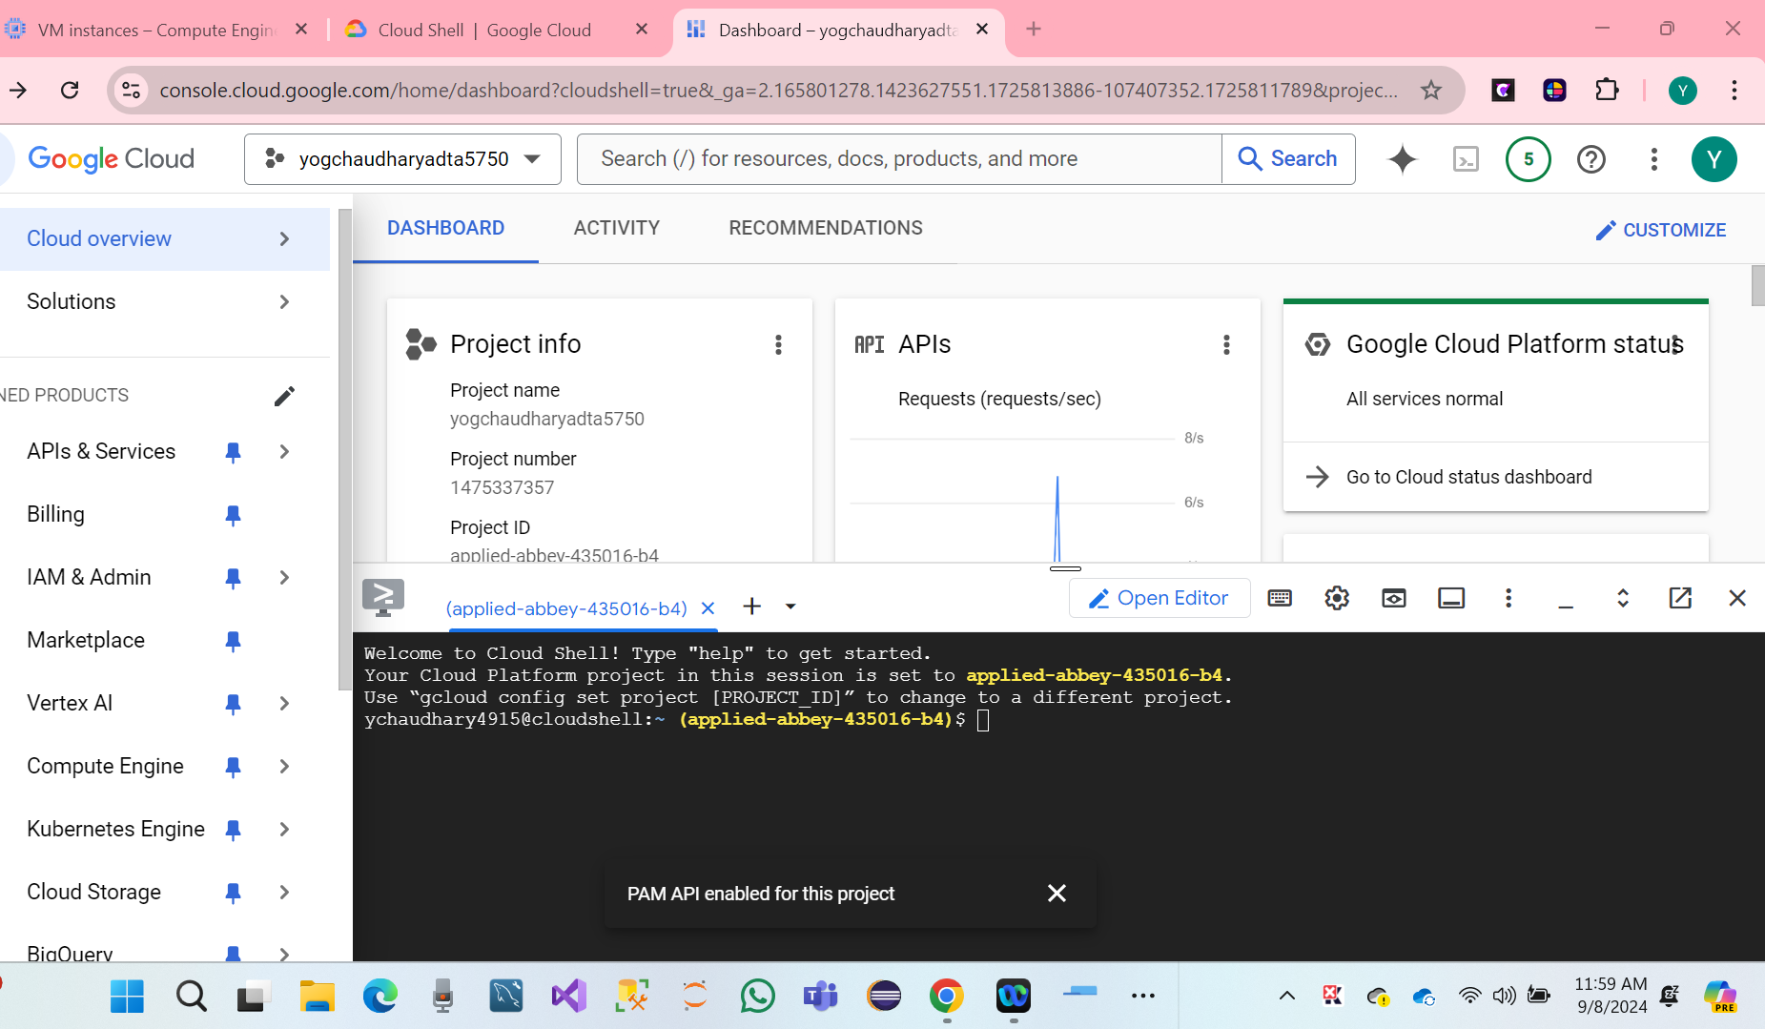

* We have a Drag tab to a new window.
* Open the cloud shell and copy and paste the code below.

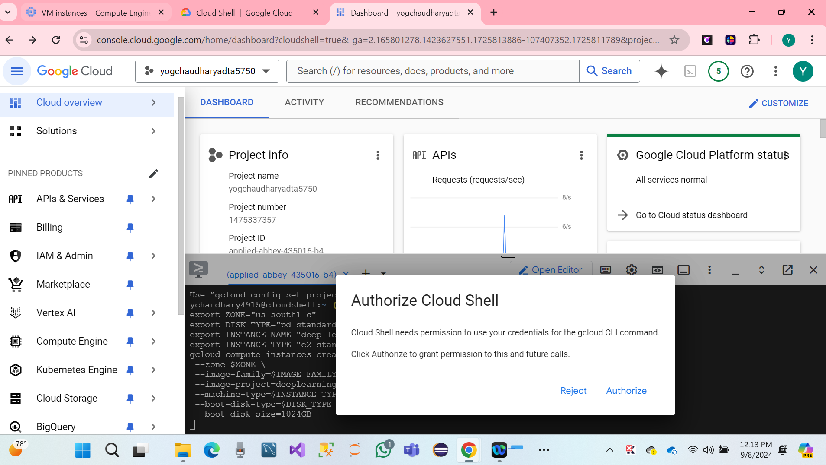

* We have to click on Cloud Shell Authorized.
* Hare we, our search bar showing Deep Learning console.
* Name of VM Instance **tf2-keras-ann-vm**
* Hare Screenshot.

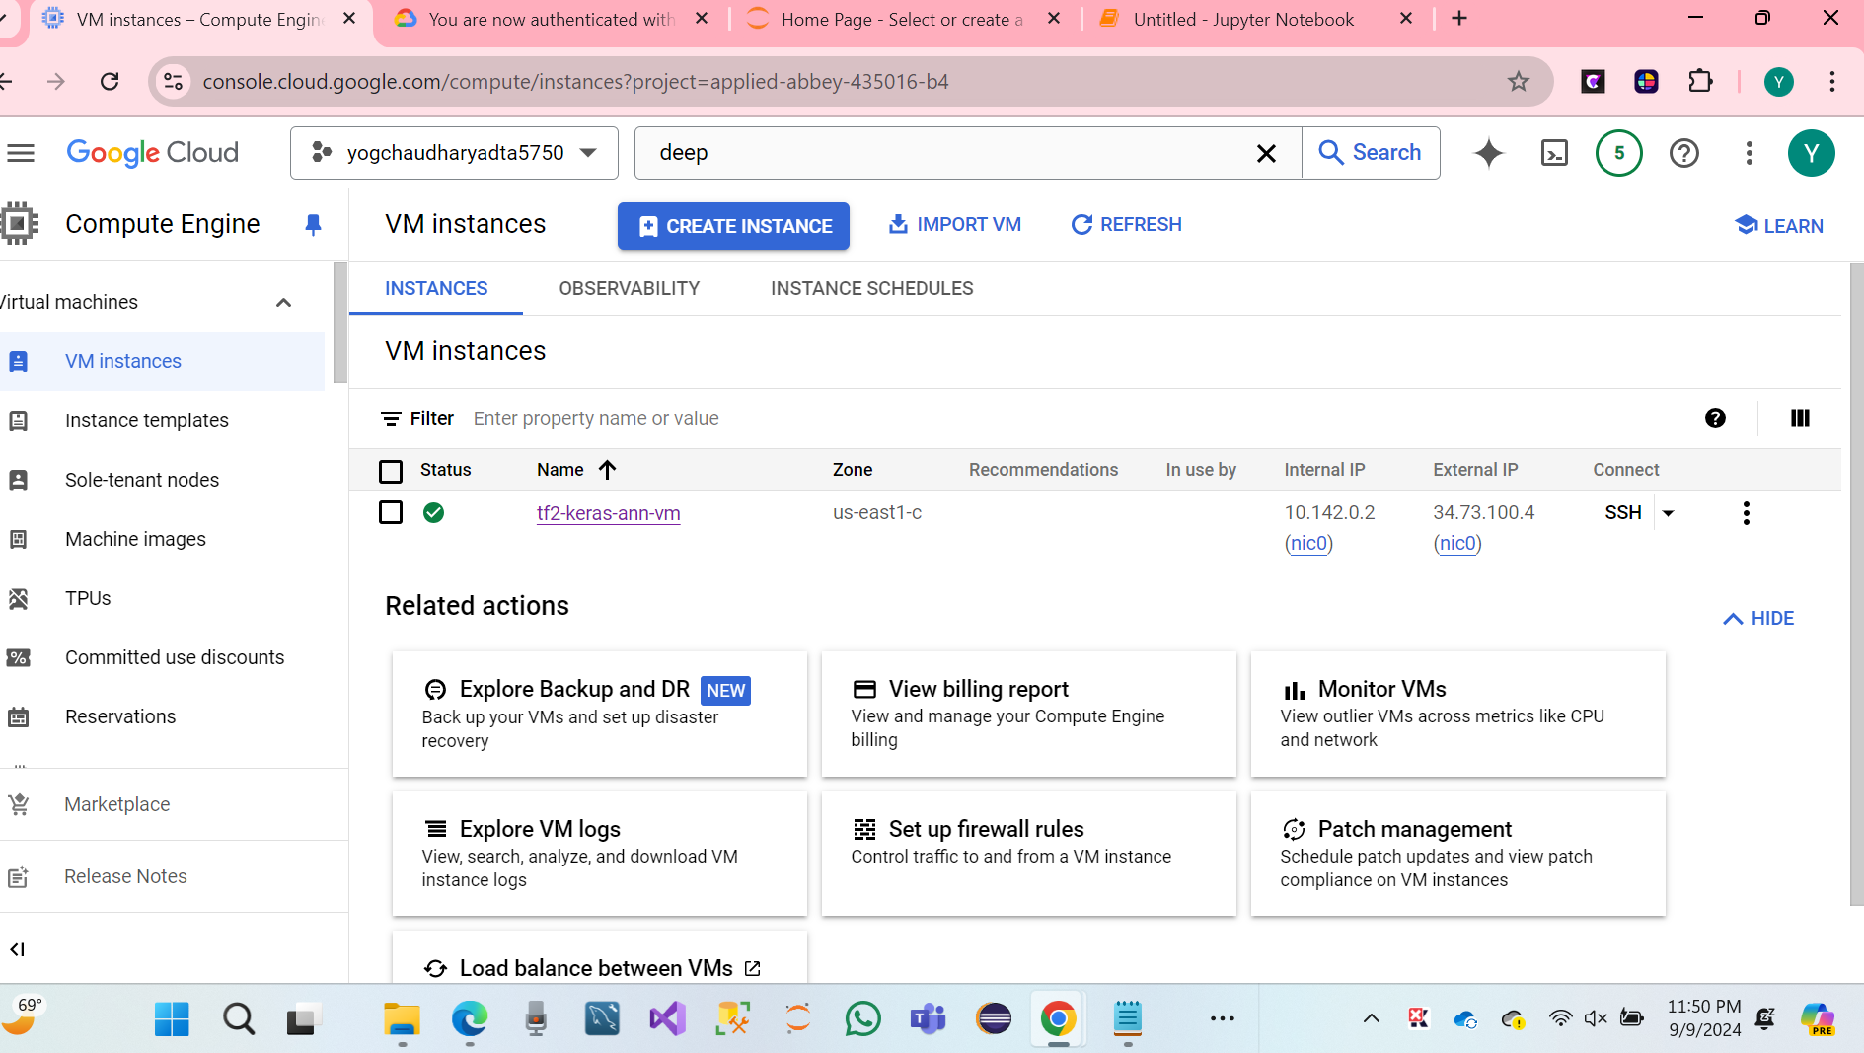

* Verify the TensorFlow Enterprises version of the VM Image.

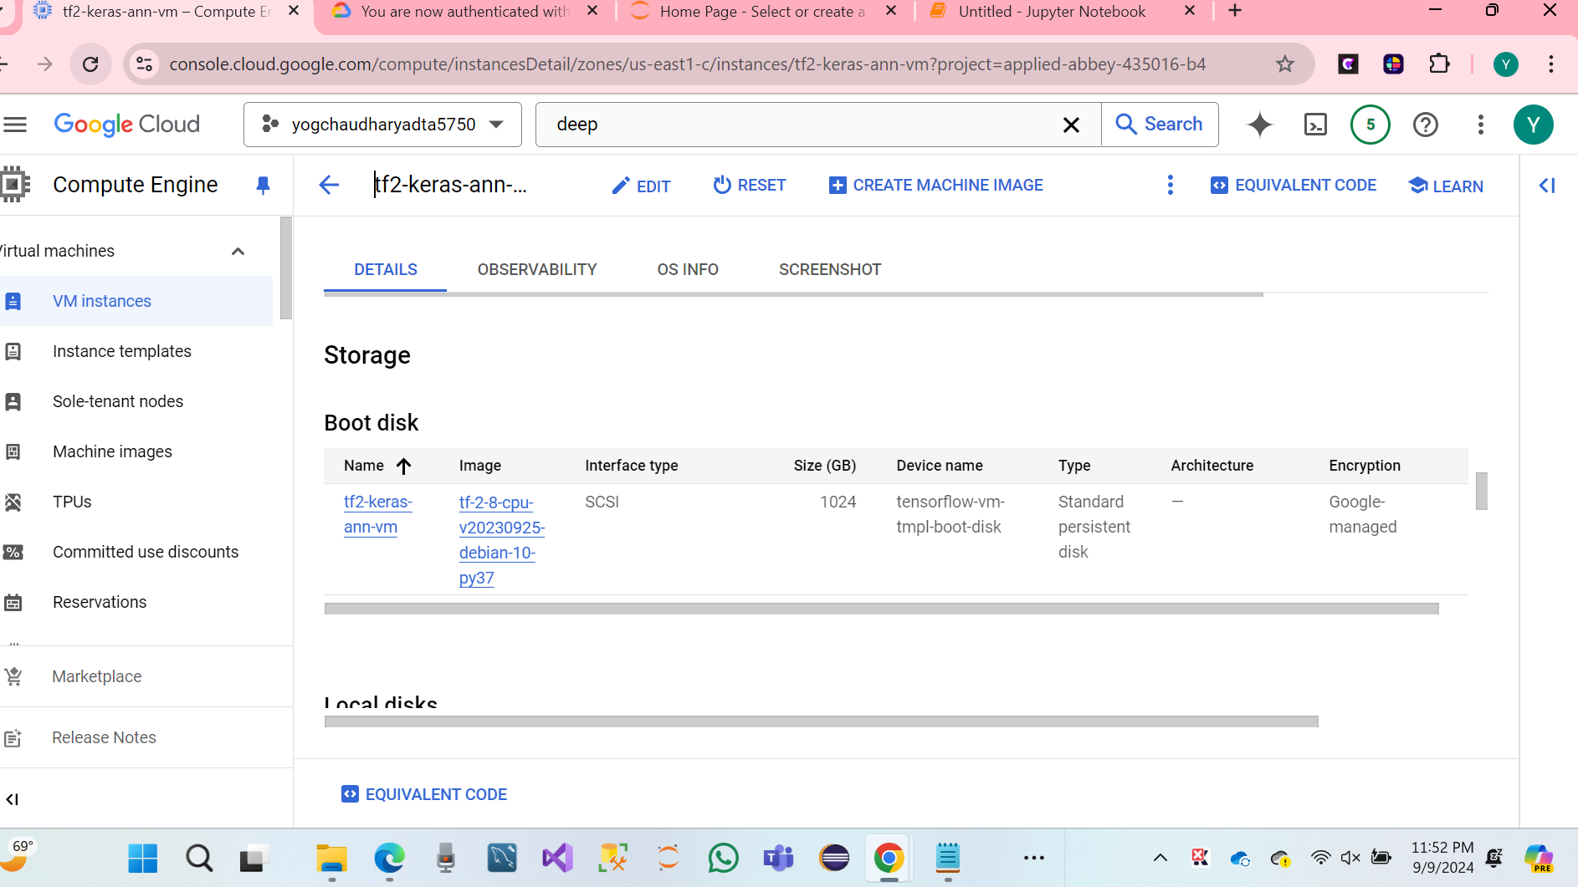

* **Deep Learning VM on GCP has been set up successfully**.

**Access GCP Remote VM Console.**

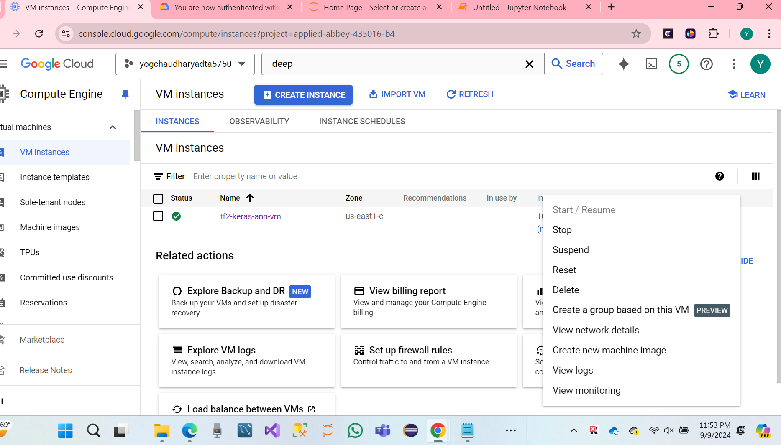

Note: Stop it when not Using.

**Install GCLOUD SDK**

* Click on the link: Download.

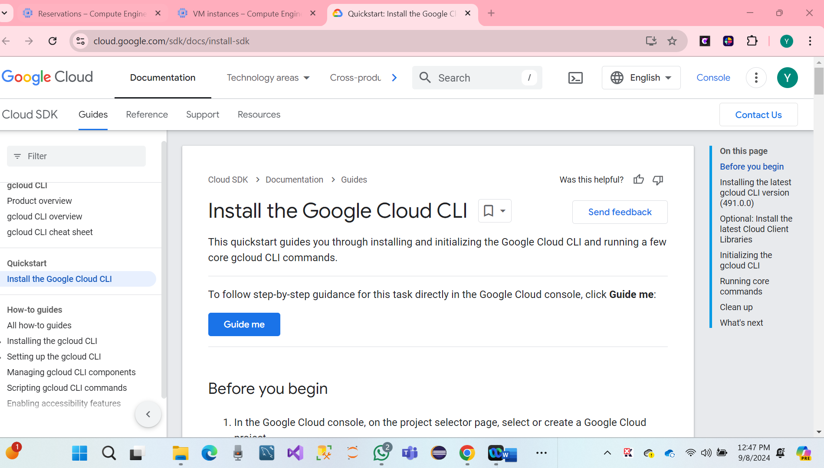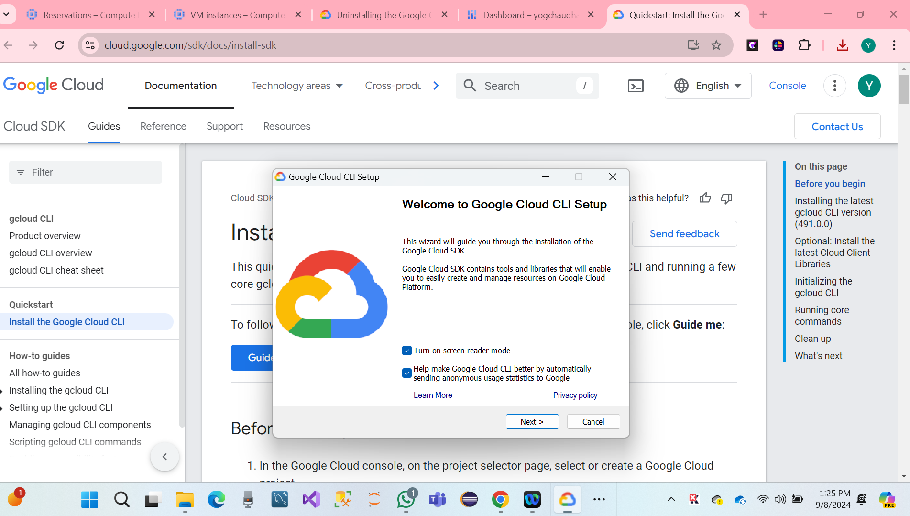

* We have to do a Finalize SDK Setting.

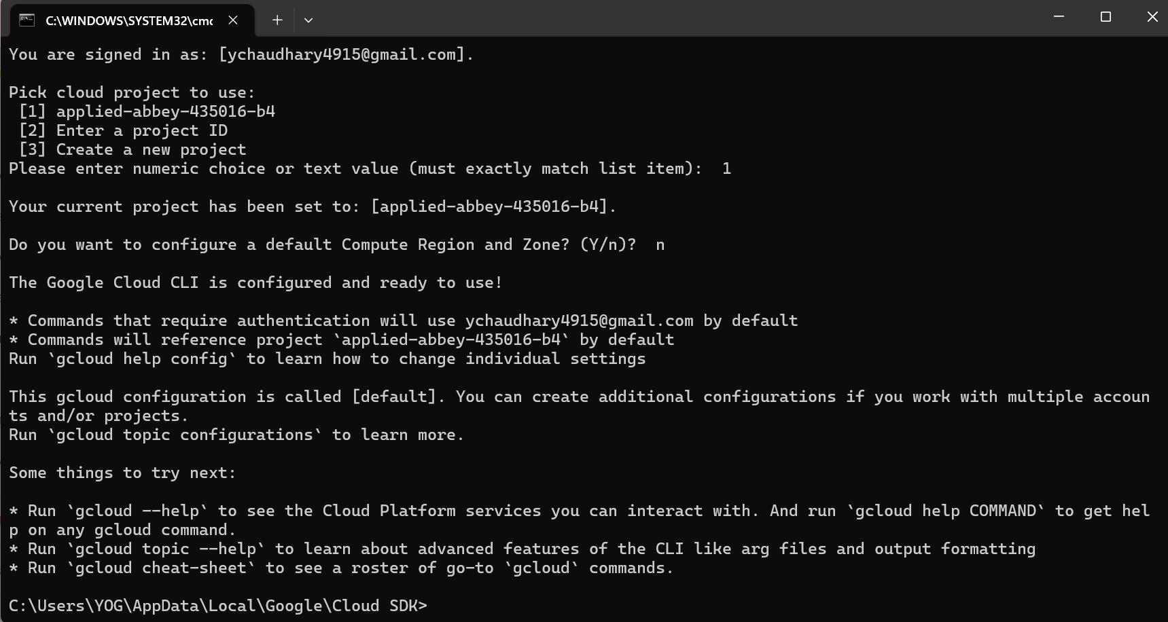

**Finally, GCLOUD SDK Has been successful.**

* Run GCCLOUD SDK Shell
* Hare Screenshot.

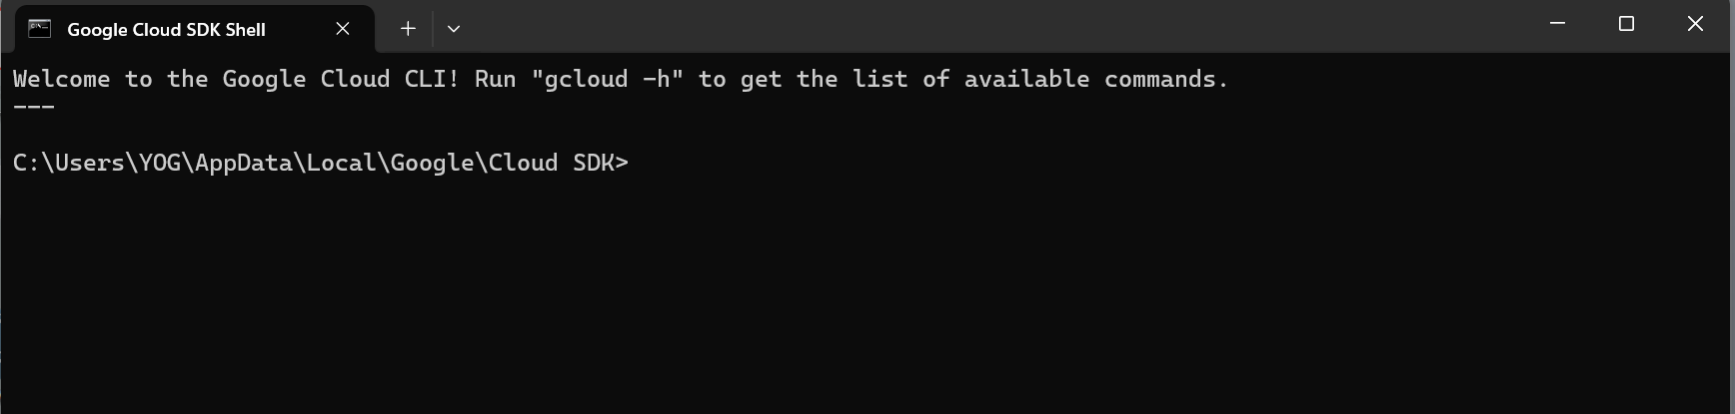

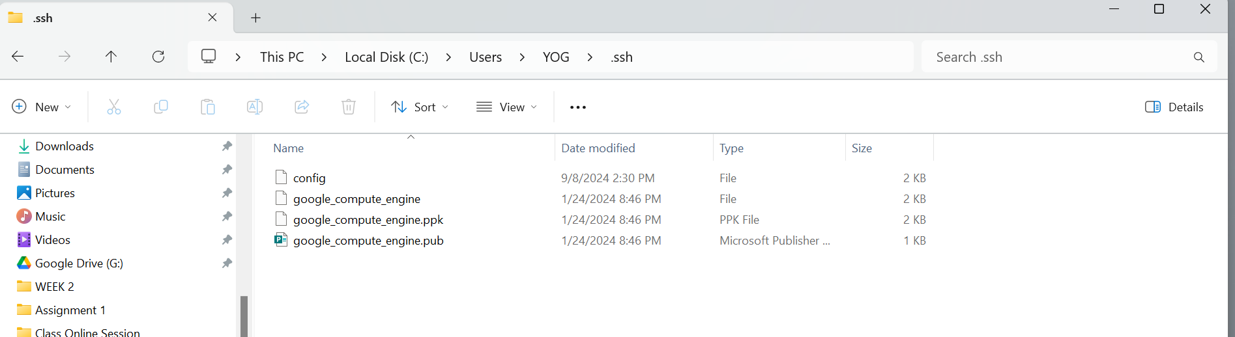

**5. PART III: Connect and Explore Remote VM Using SSH (5 Points)**

Question 3.1:

Based on the lectures, open an SSH connection from the local computer to the remote VM

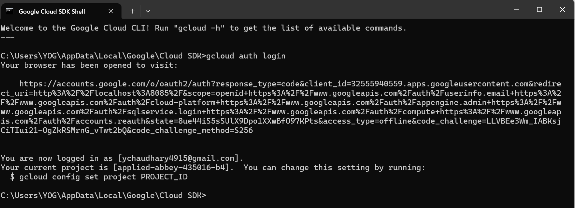

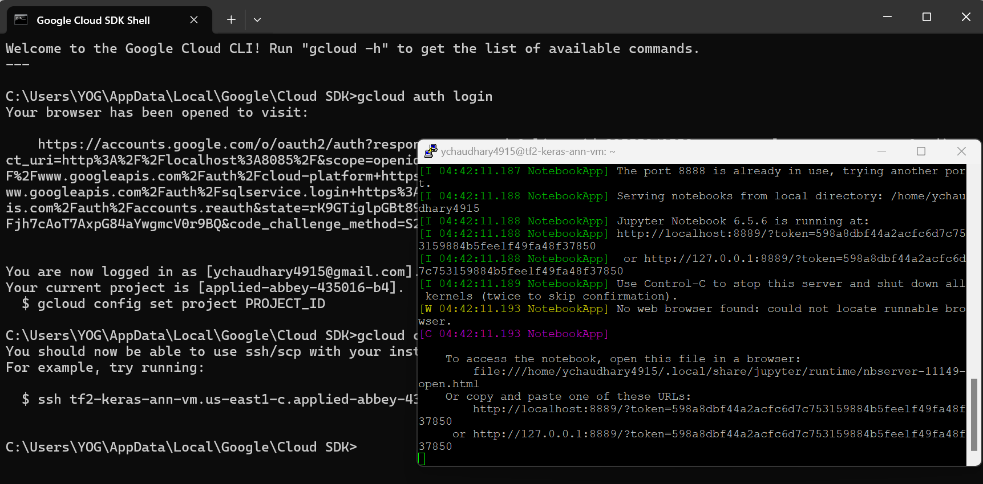

Question 3.2

Using the basic Linux command lines to explore the contents of the home directory

* Pwd
* whoami
* Ls -l
* Ls -all

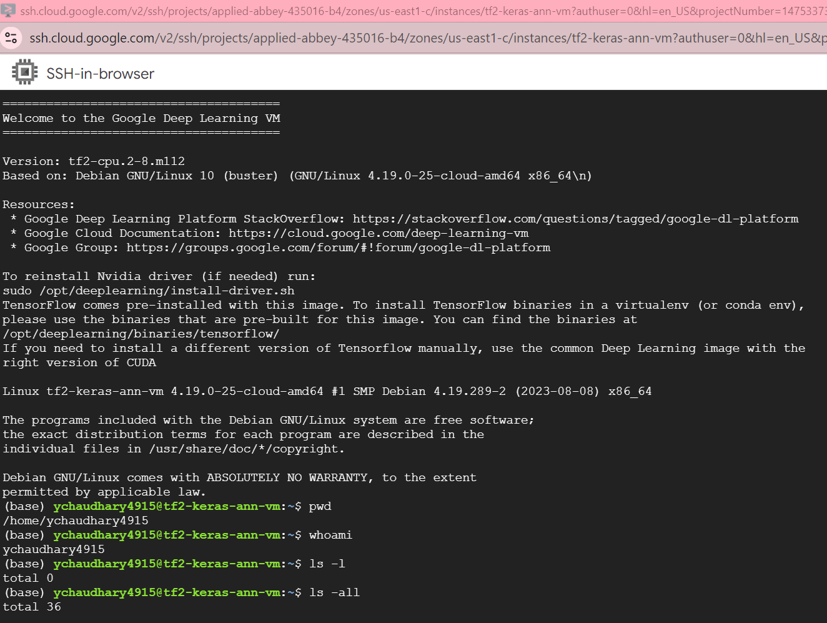

Question 3.3

Create a new sub-folder named “JPTR_NTBK” under the home directory

* Mkdir JPTR_NTBK
* Cd JPTR_NTBK

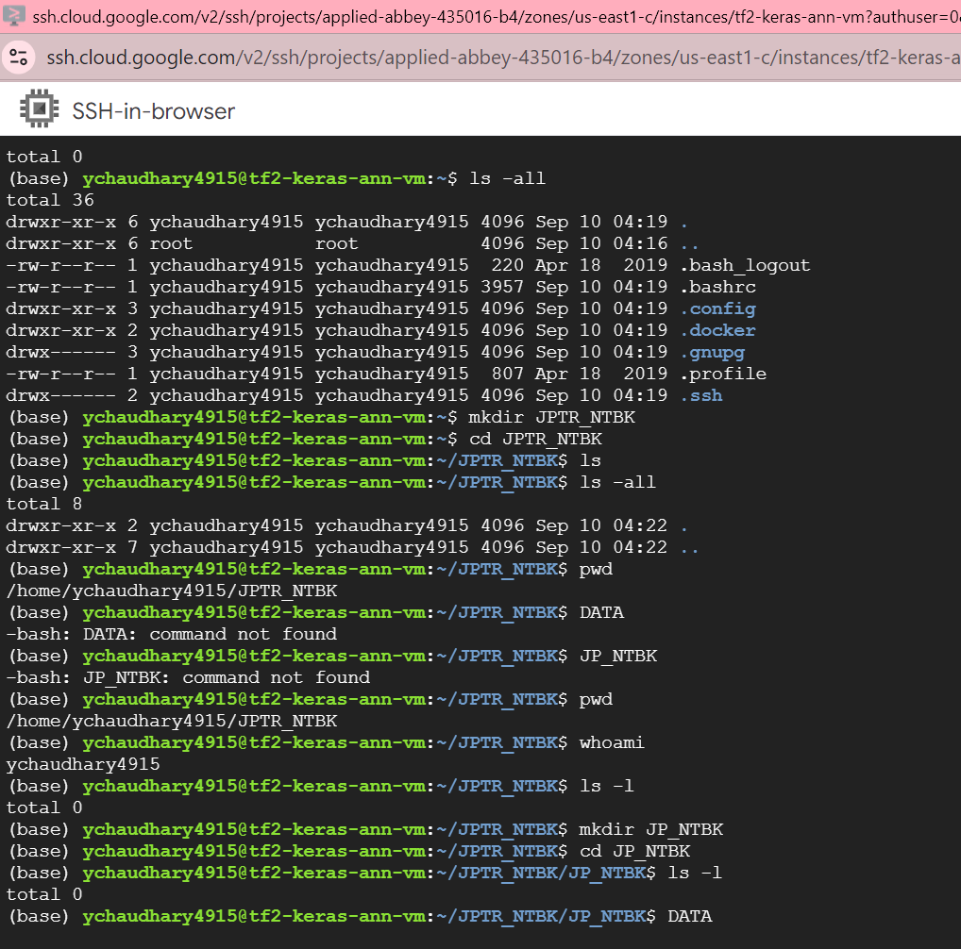

Question 3.4

Change the current directory to the newly created folder

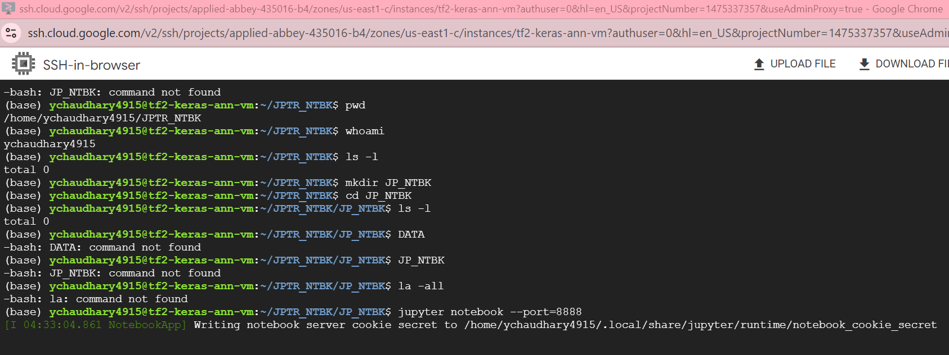

**6. PART IV: Start and Connect to Jupyter Notebook in Remote VM (20 Points)**

**Question 4.1:**

Based on the lectures, start the Jupyter Notebook server in the remote virtual machine

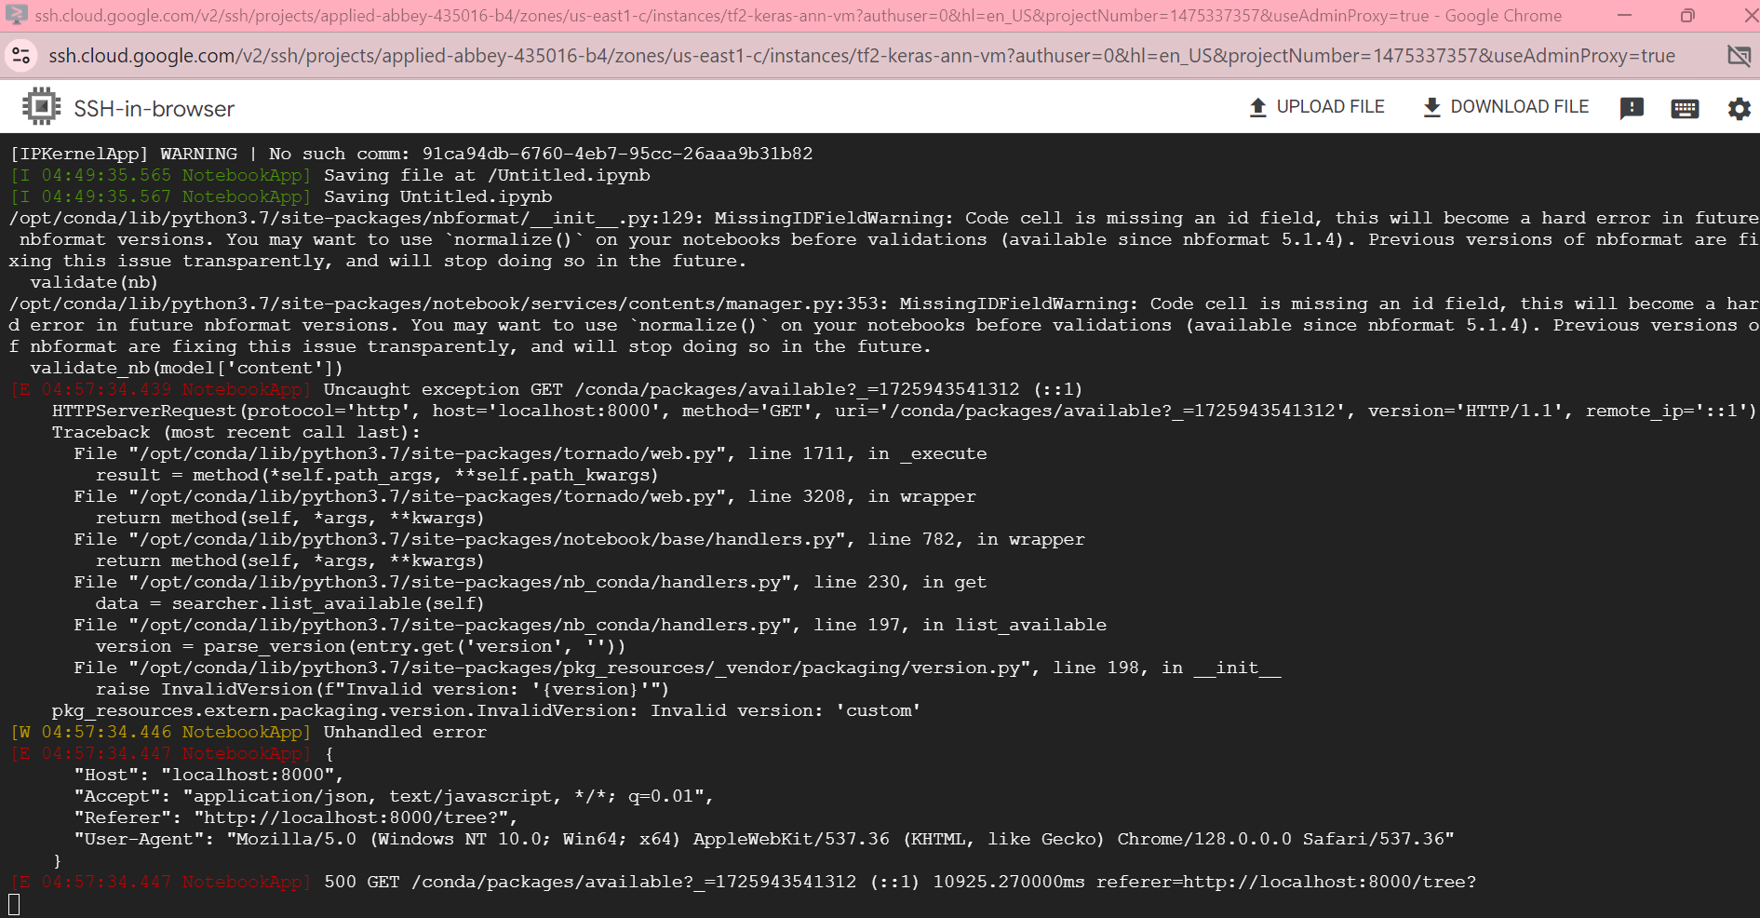

**Question 4.2:**

**gcloud compute ssh ychaudhary4915@tf2-keras-ann-vm --project applied-abbey-435016-b4 --zone us-east1-c -- -L 8000:localhost:8888**

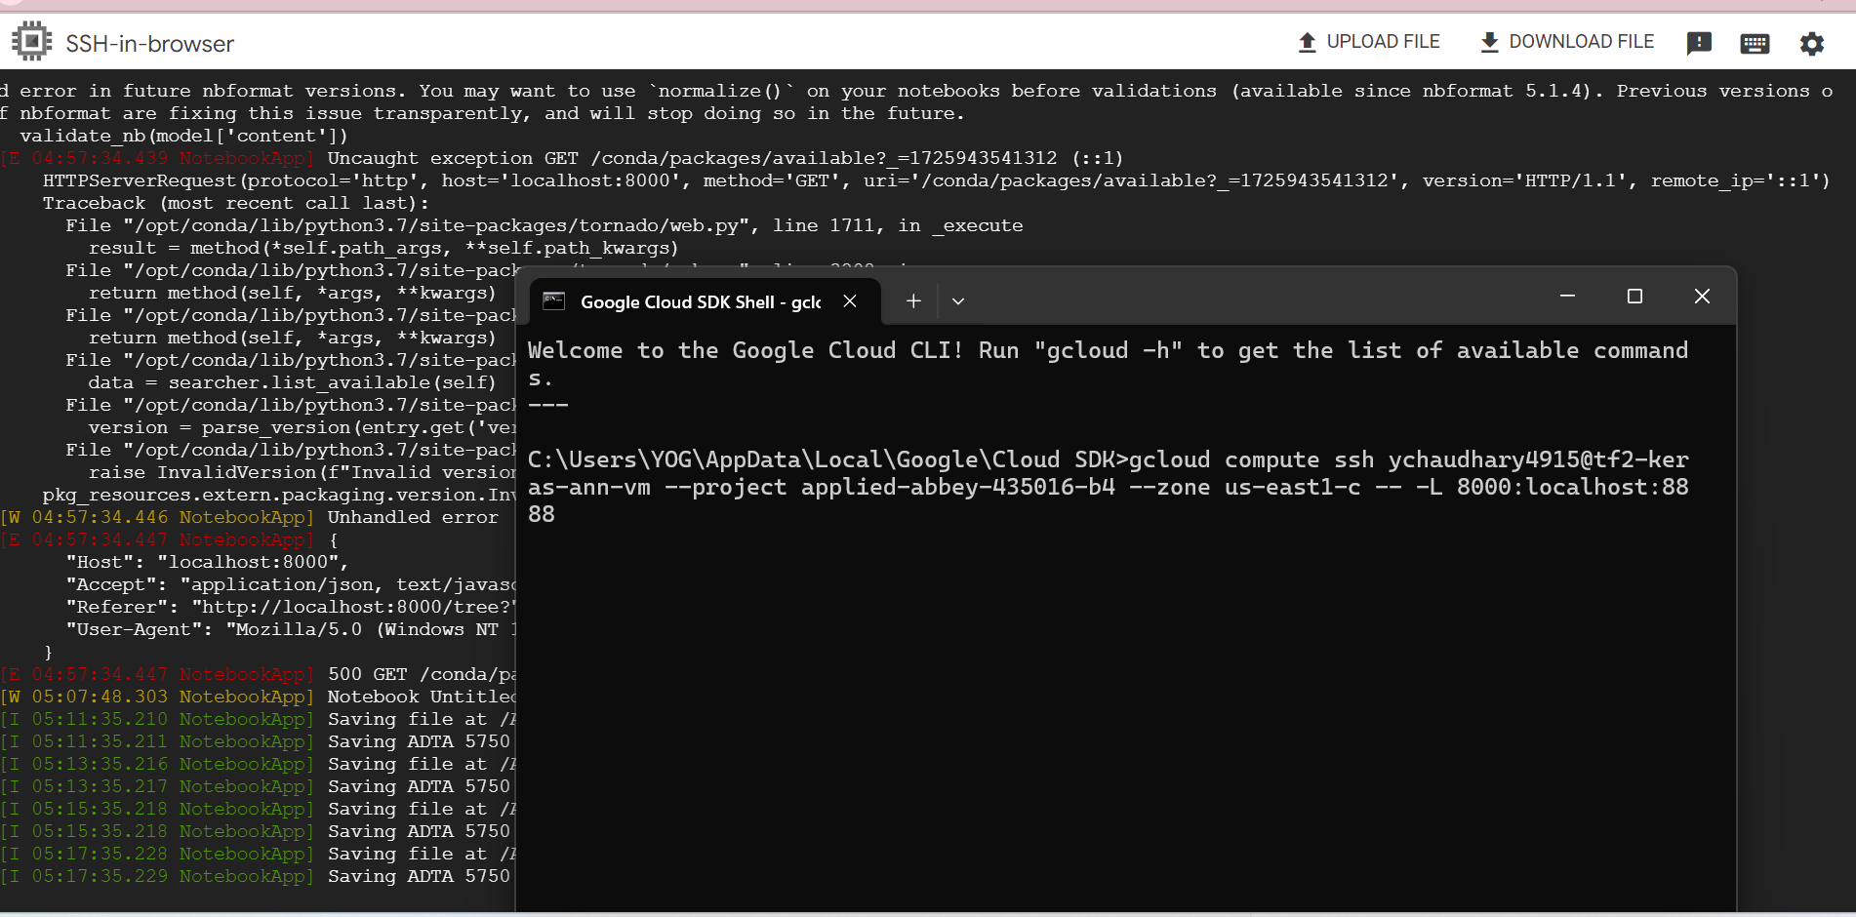

**Question 4.3:**

Use Jupyter Notebook that is currently running in the Remote Server (in a browser on the local computer).

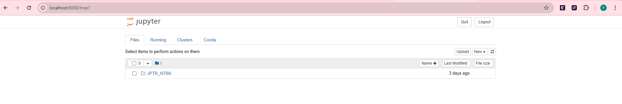

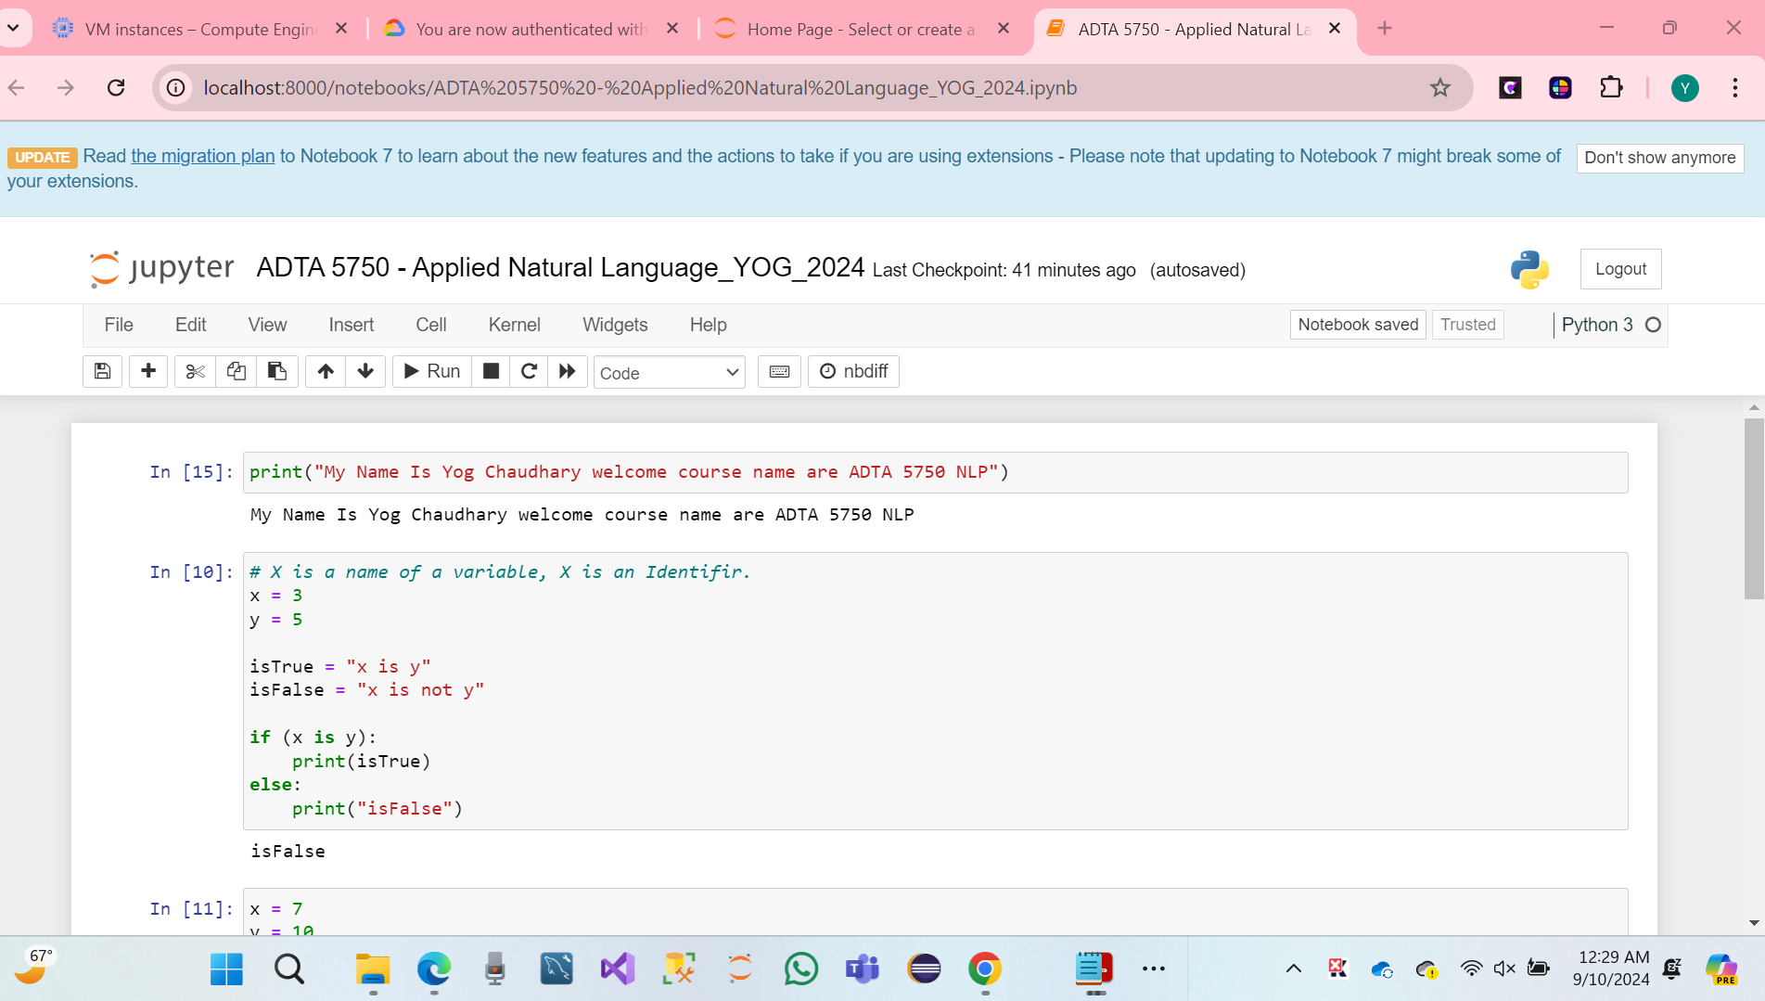

**7. PART V: Create Service Account for GCP Project (20 Points)**

**Create a Service Account for GCP, Project**

* Click on Access Google Chrome browser and open the IAM & Admin Services accounts page.
* Click IAM & Admin to open a drop-down menu.
* Click on Select Services accounts.

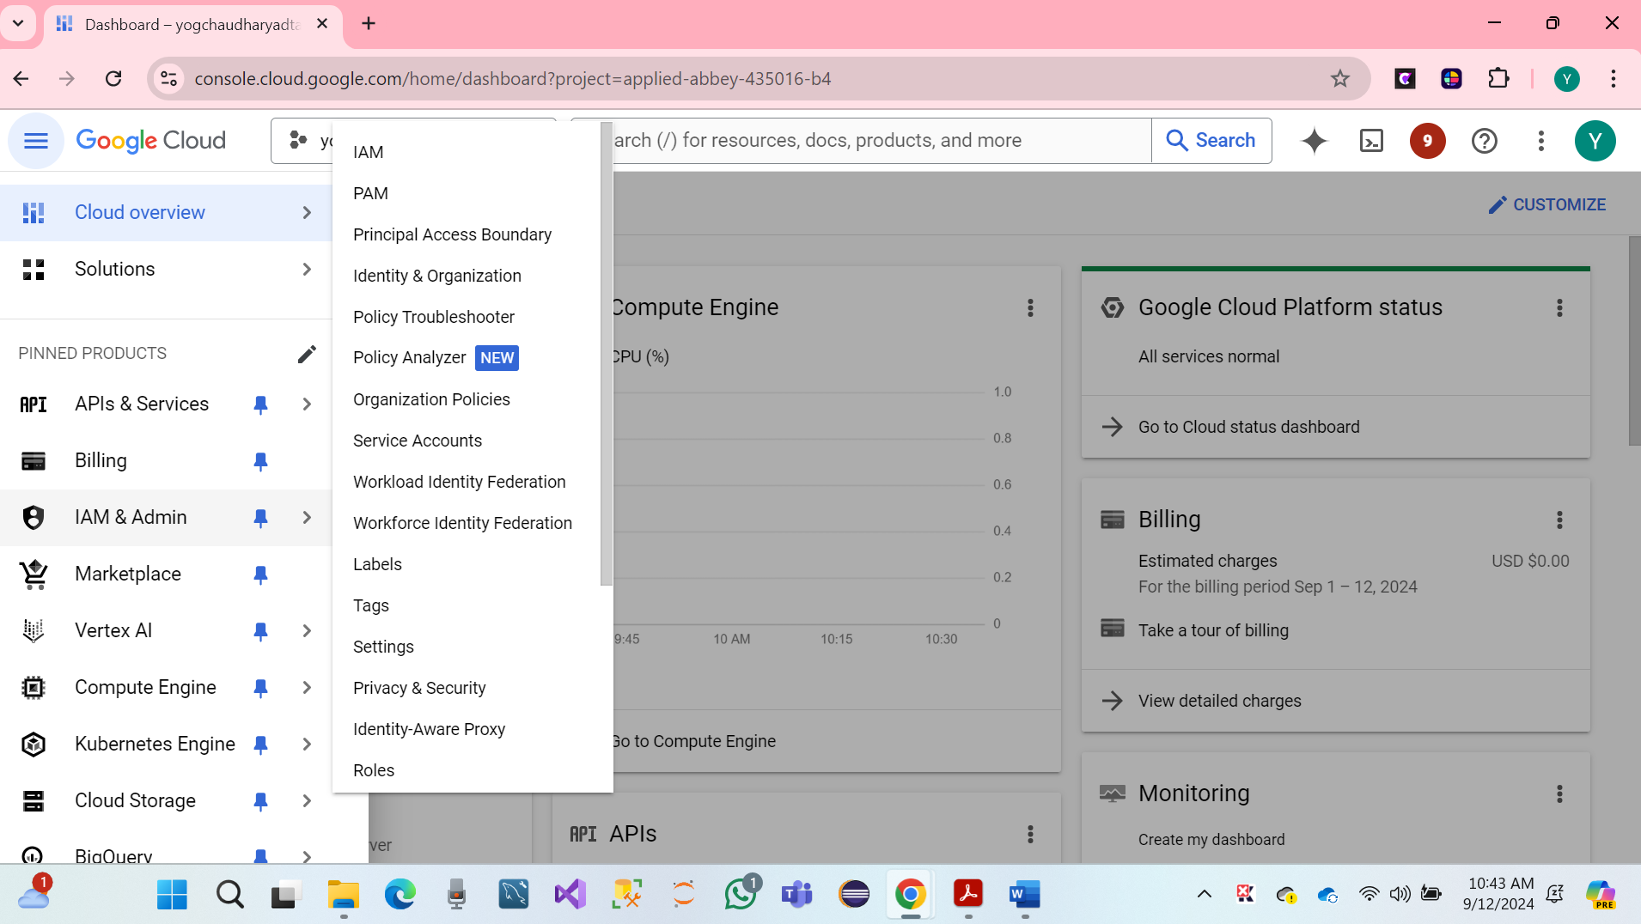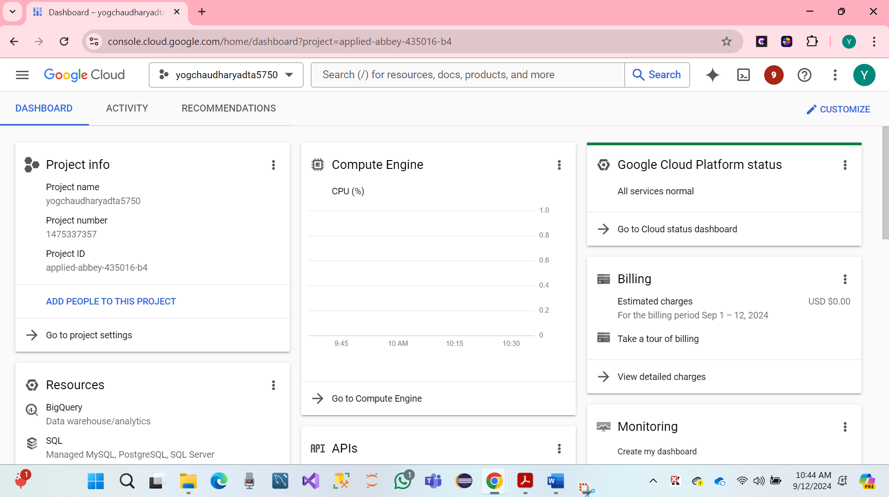

* Click to select a project name **yogchaudharyadta5750**
* Hare Screenshot.

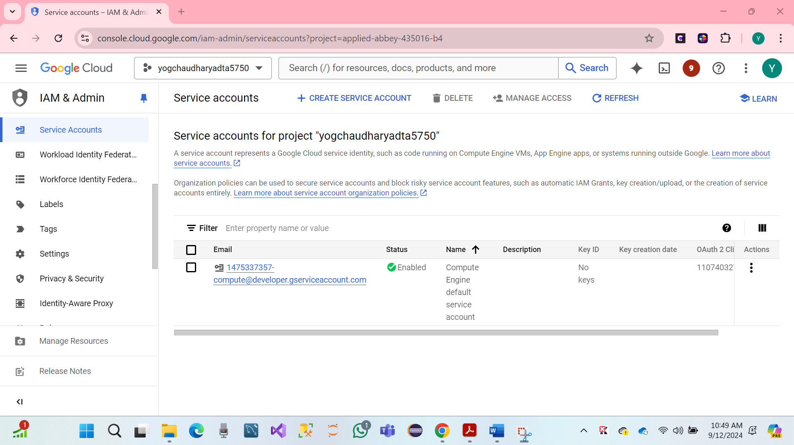

* Click to start a creative service account with an automotive name.

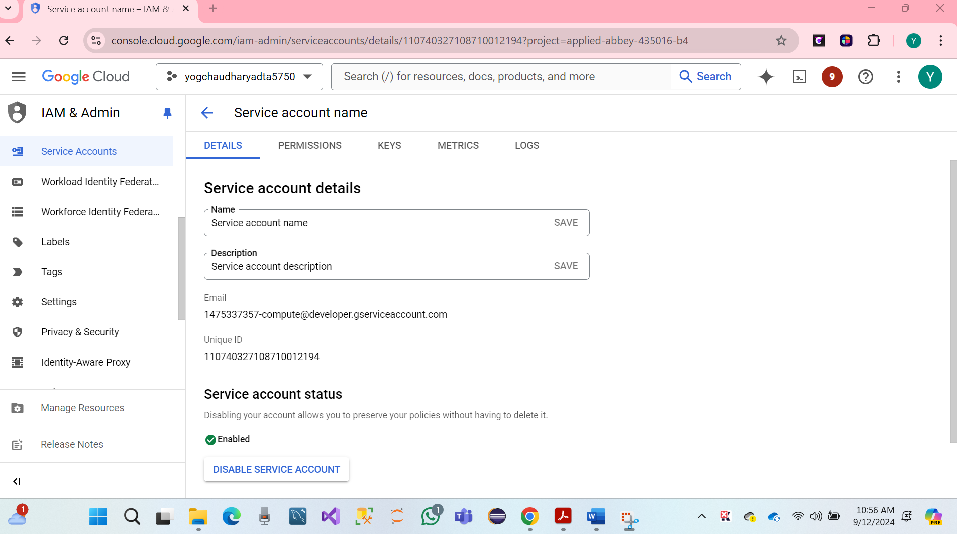 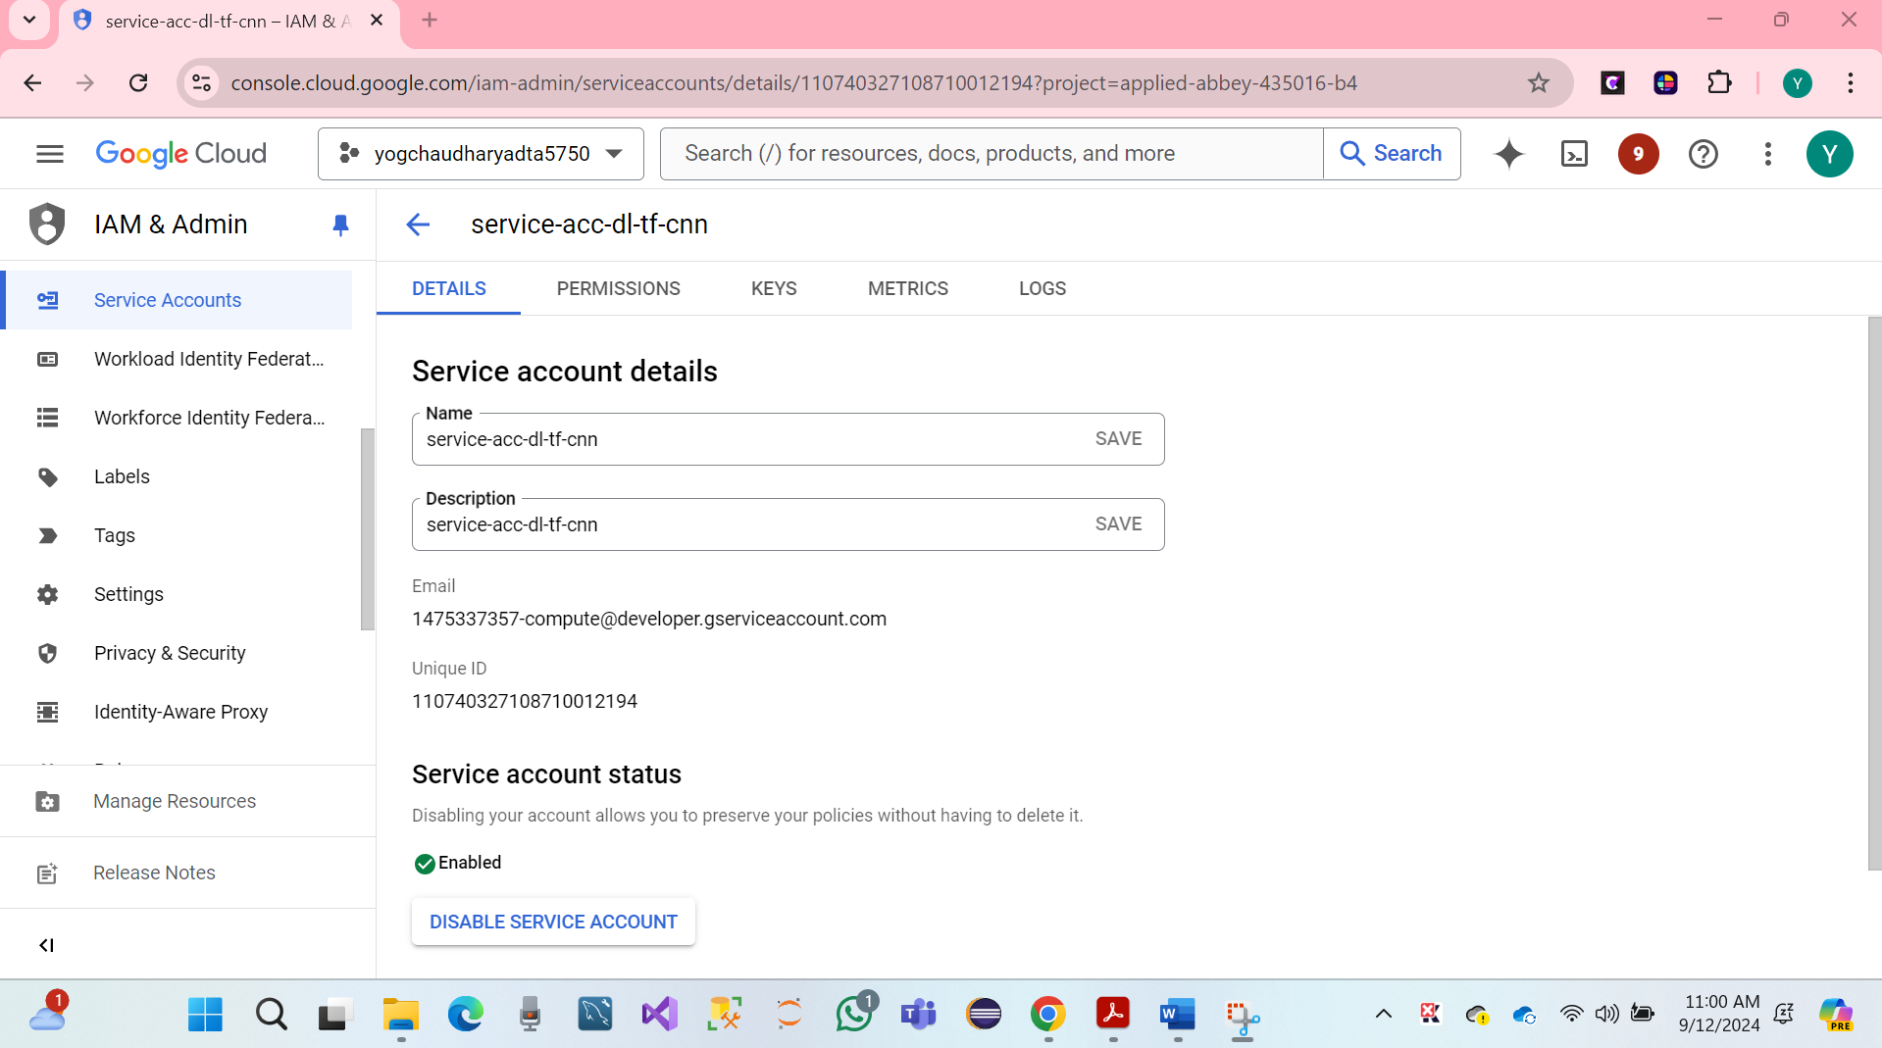

* We have a click to start a creative service account with an automotive name renamed.
* **service-acc-dl-tf-cnn**
* Click on Create and Services account details or permission to access the project role Owner.
* click on Create continues.

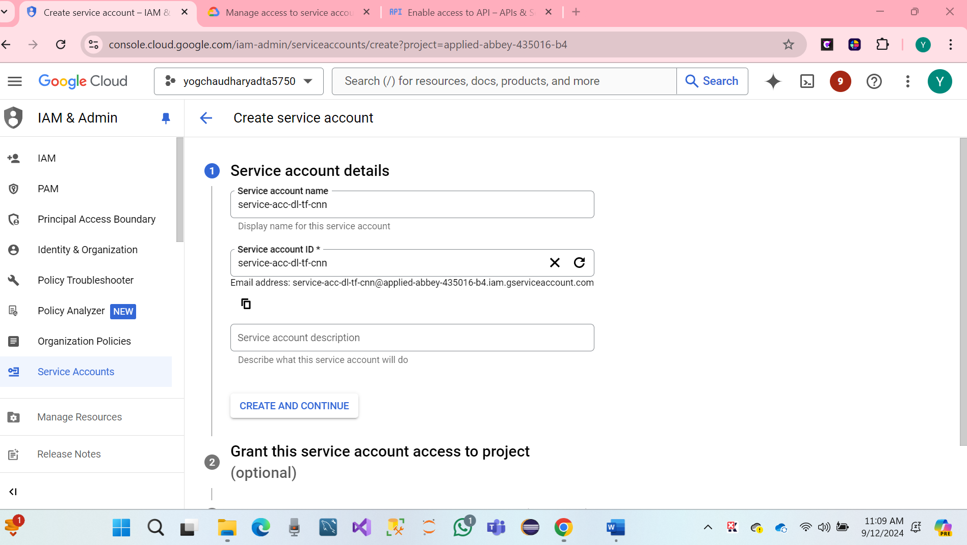

* Click on Selected Owner and Continue.

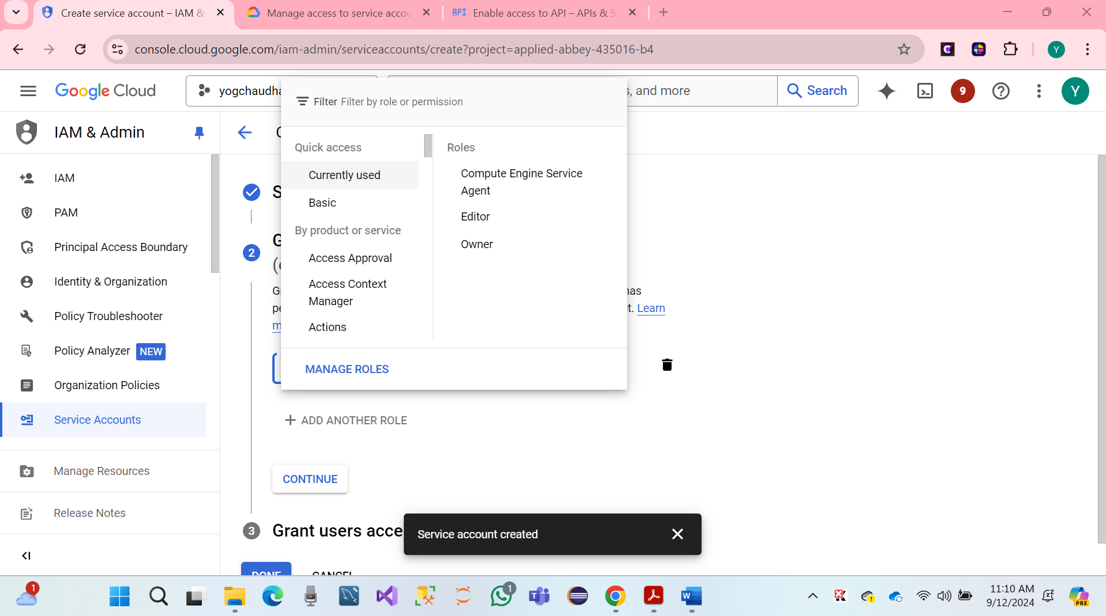

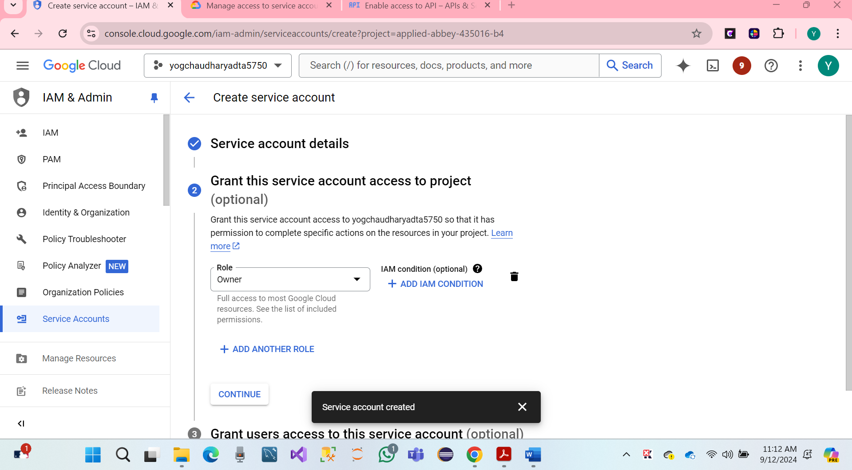

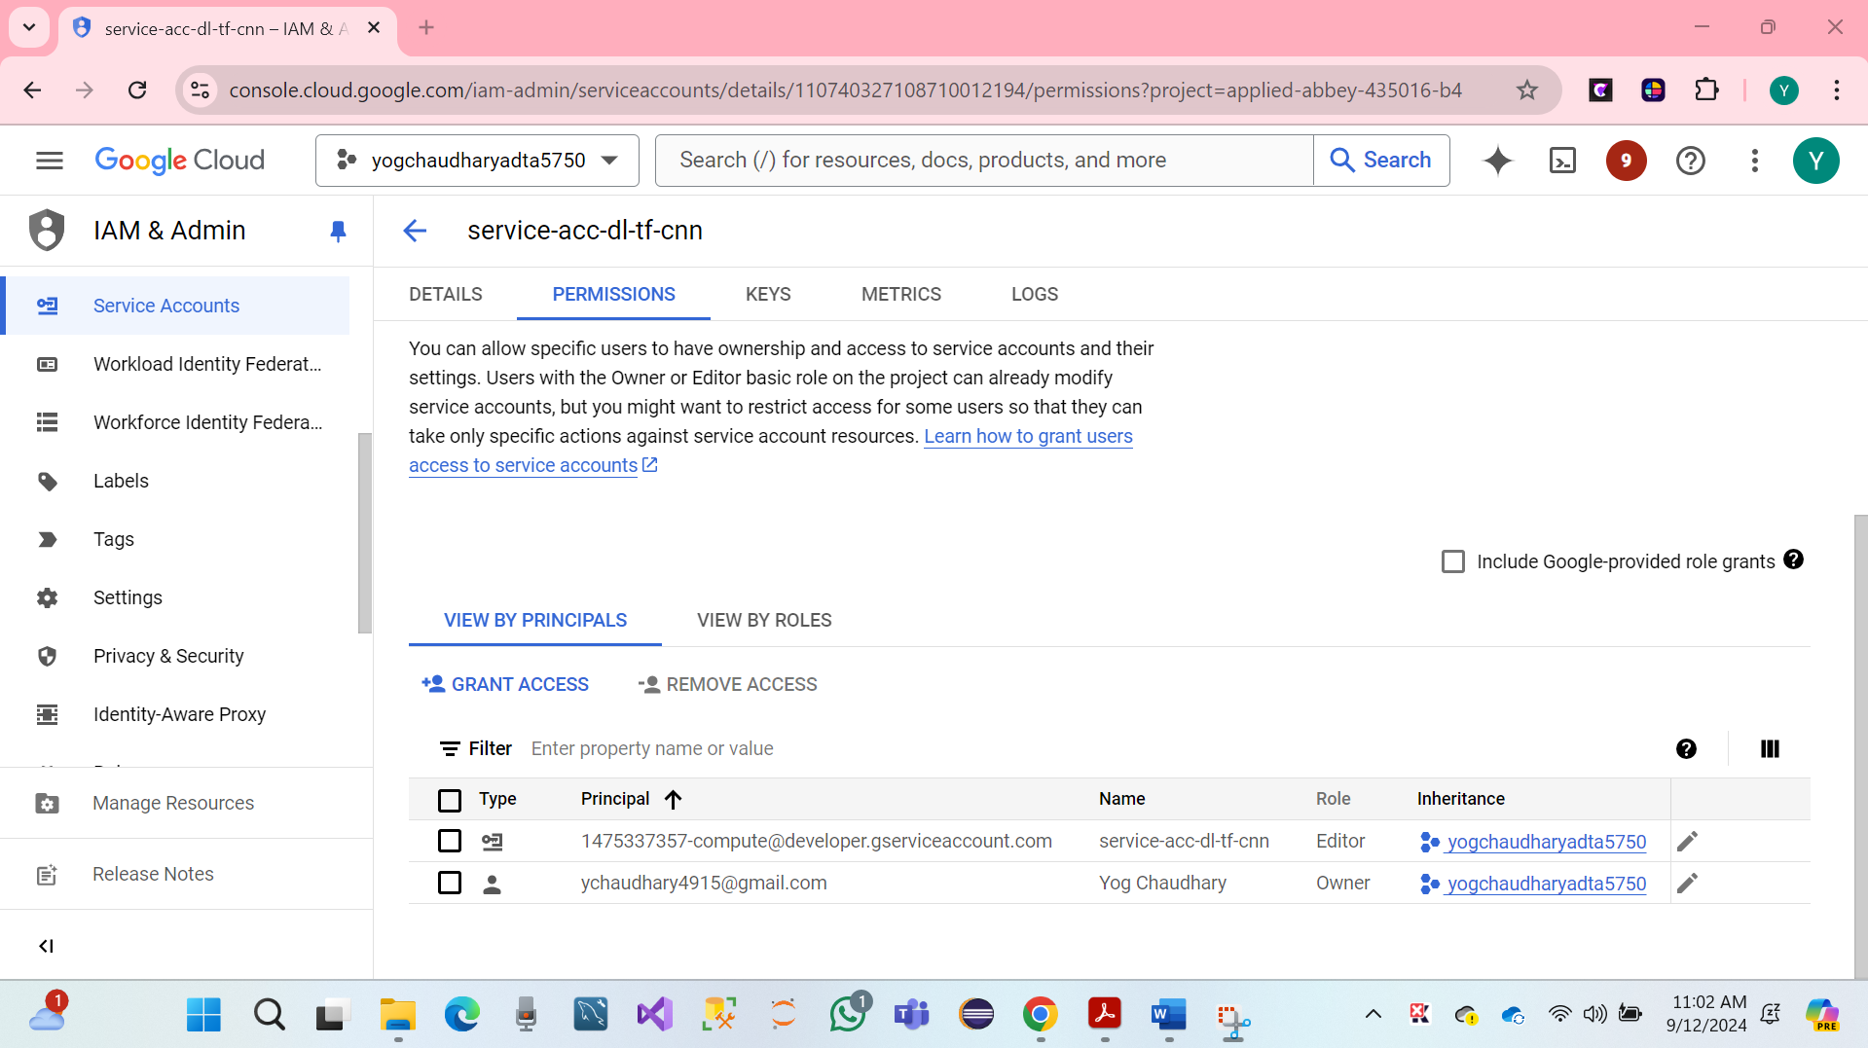

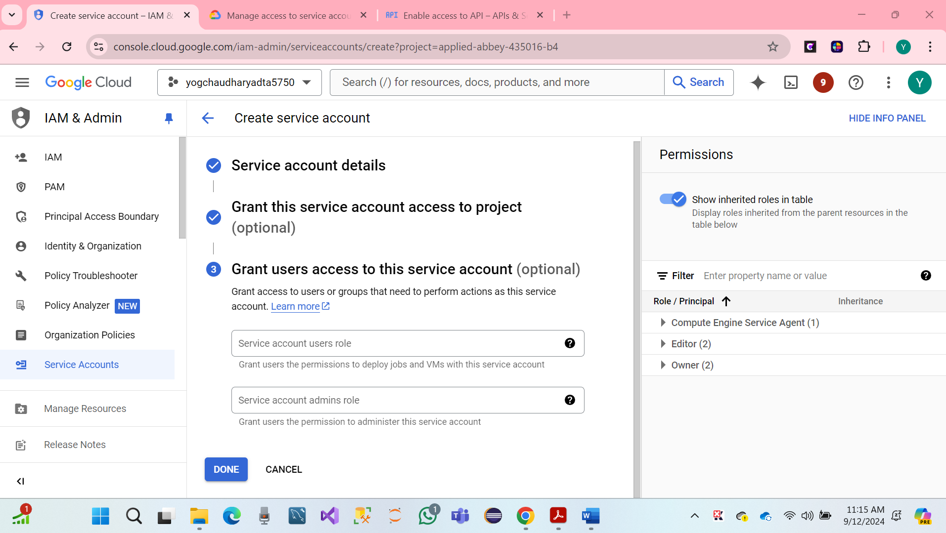

* Created to Grant user access to the service account name [ychaudhary4915@gmail.com](mailto:ychaudhary4915@gmail.com)
* Hare Screenshot

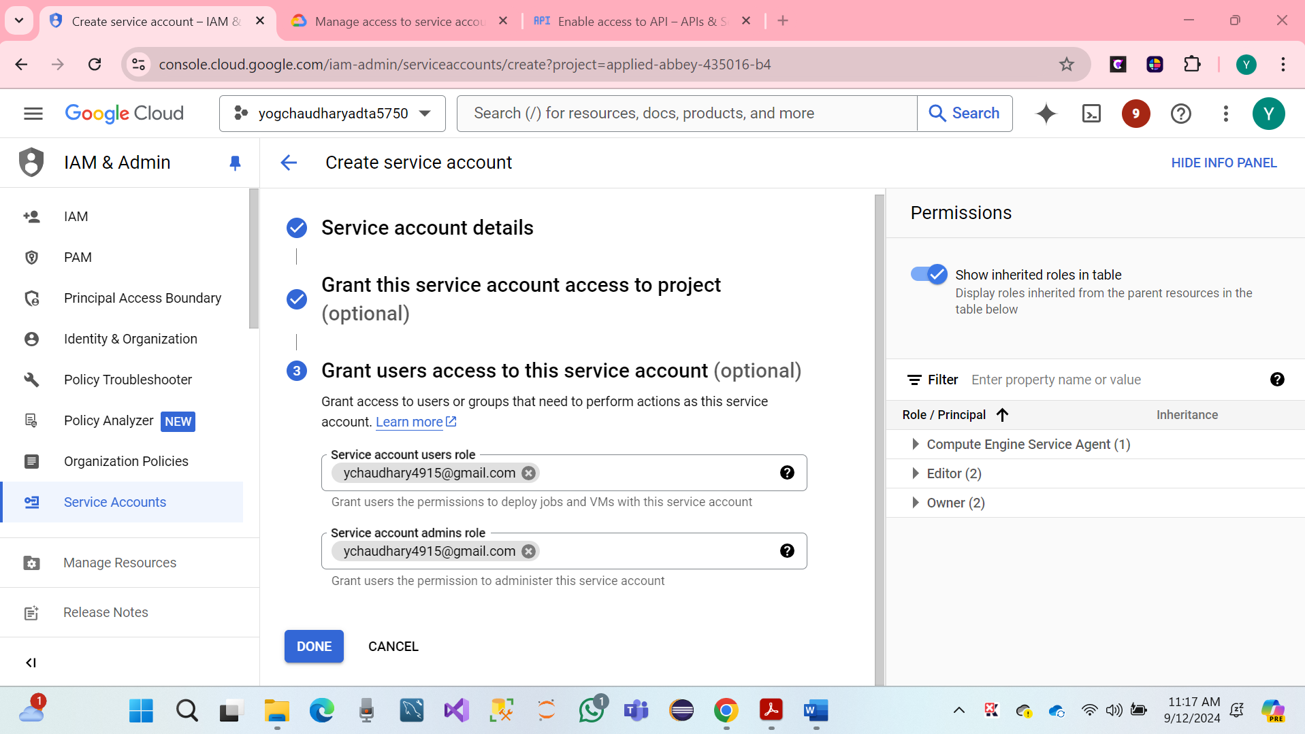

* Click on Done and Continues.

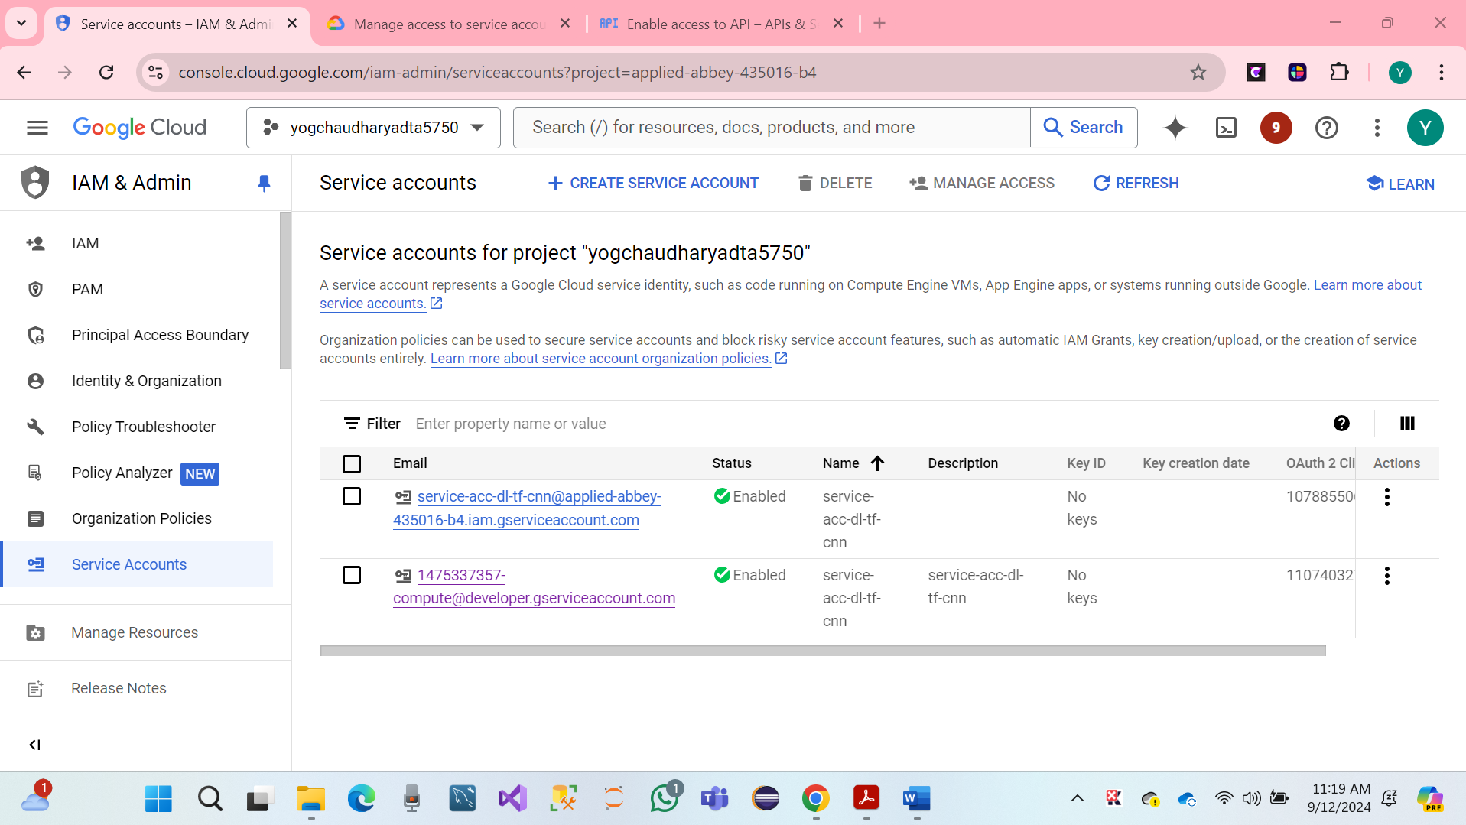

**Finally, it’s done, and the service account has been created successfully.**

**8. PART VI: Set Up Natural Language API for GCP Project (20 Points**

We have created a Natural Language API, Access GCP project Dashboard name project as **yogchaudharyadta5750**

* Click on Dashboard.
* Click on API Services.

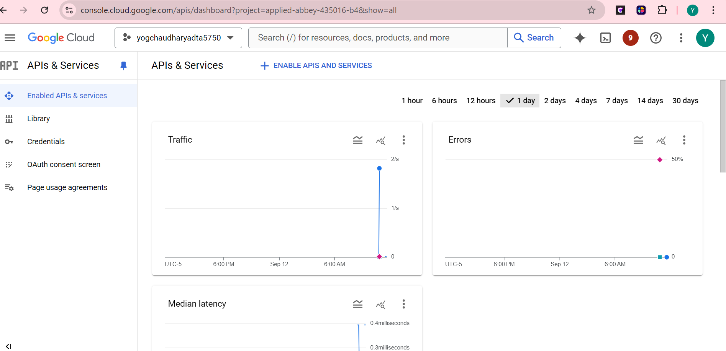

* Click on API services Search the browser dropdown and enter Natural language.

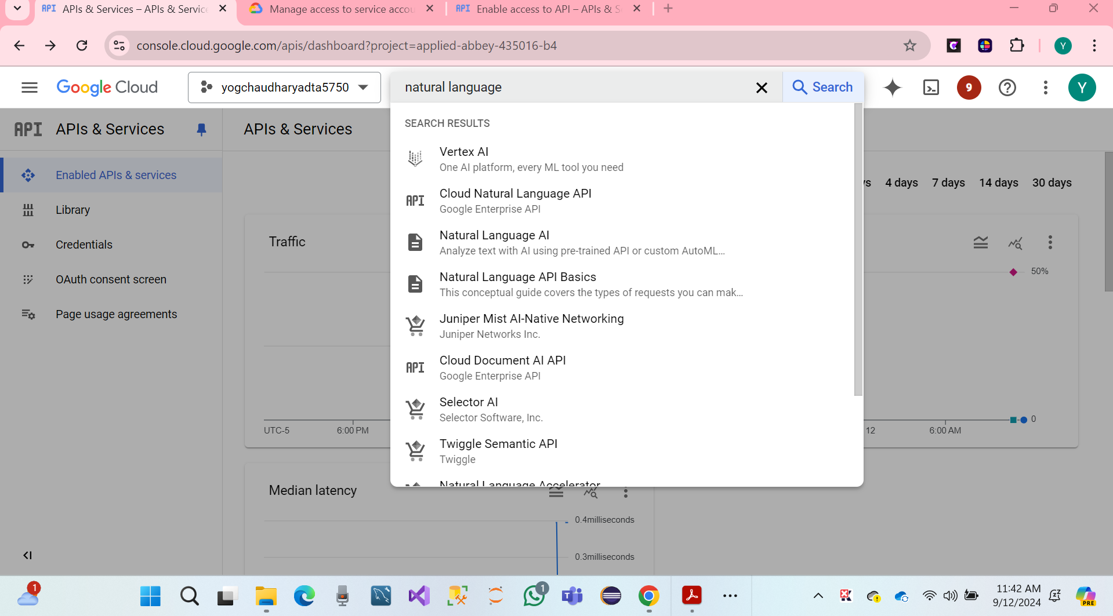

* Again, we have to click on Enable **for Cloud Natural Language API.**

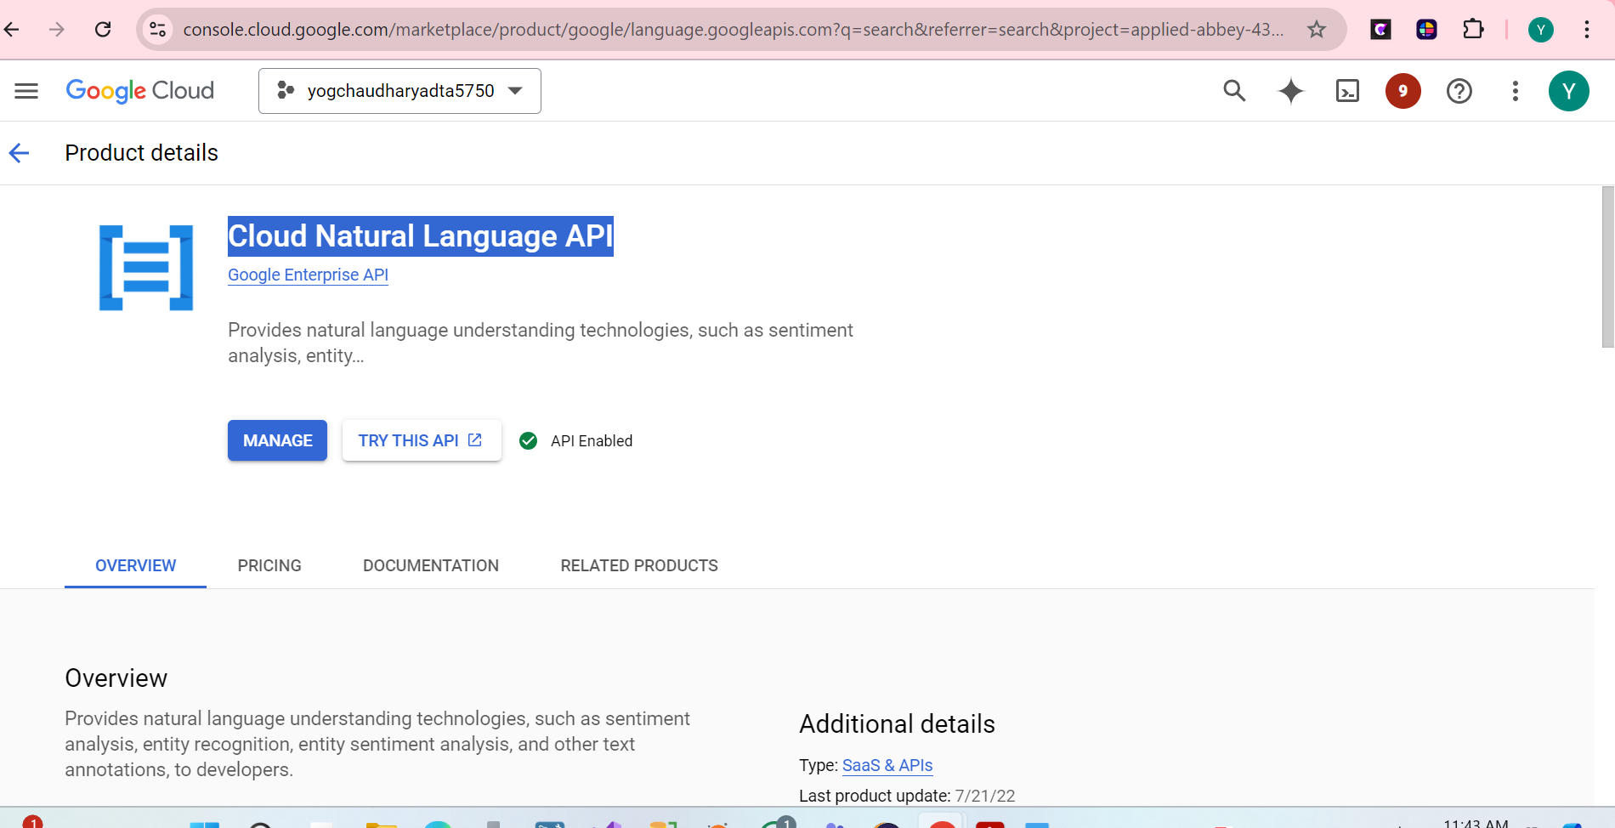

We have done a **Setup Services account for VM Instance.**

* Click on Name of VM Instance, and open and stop the remote deep learning server.

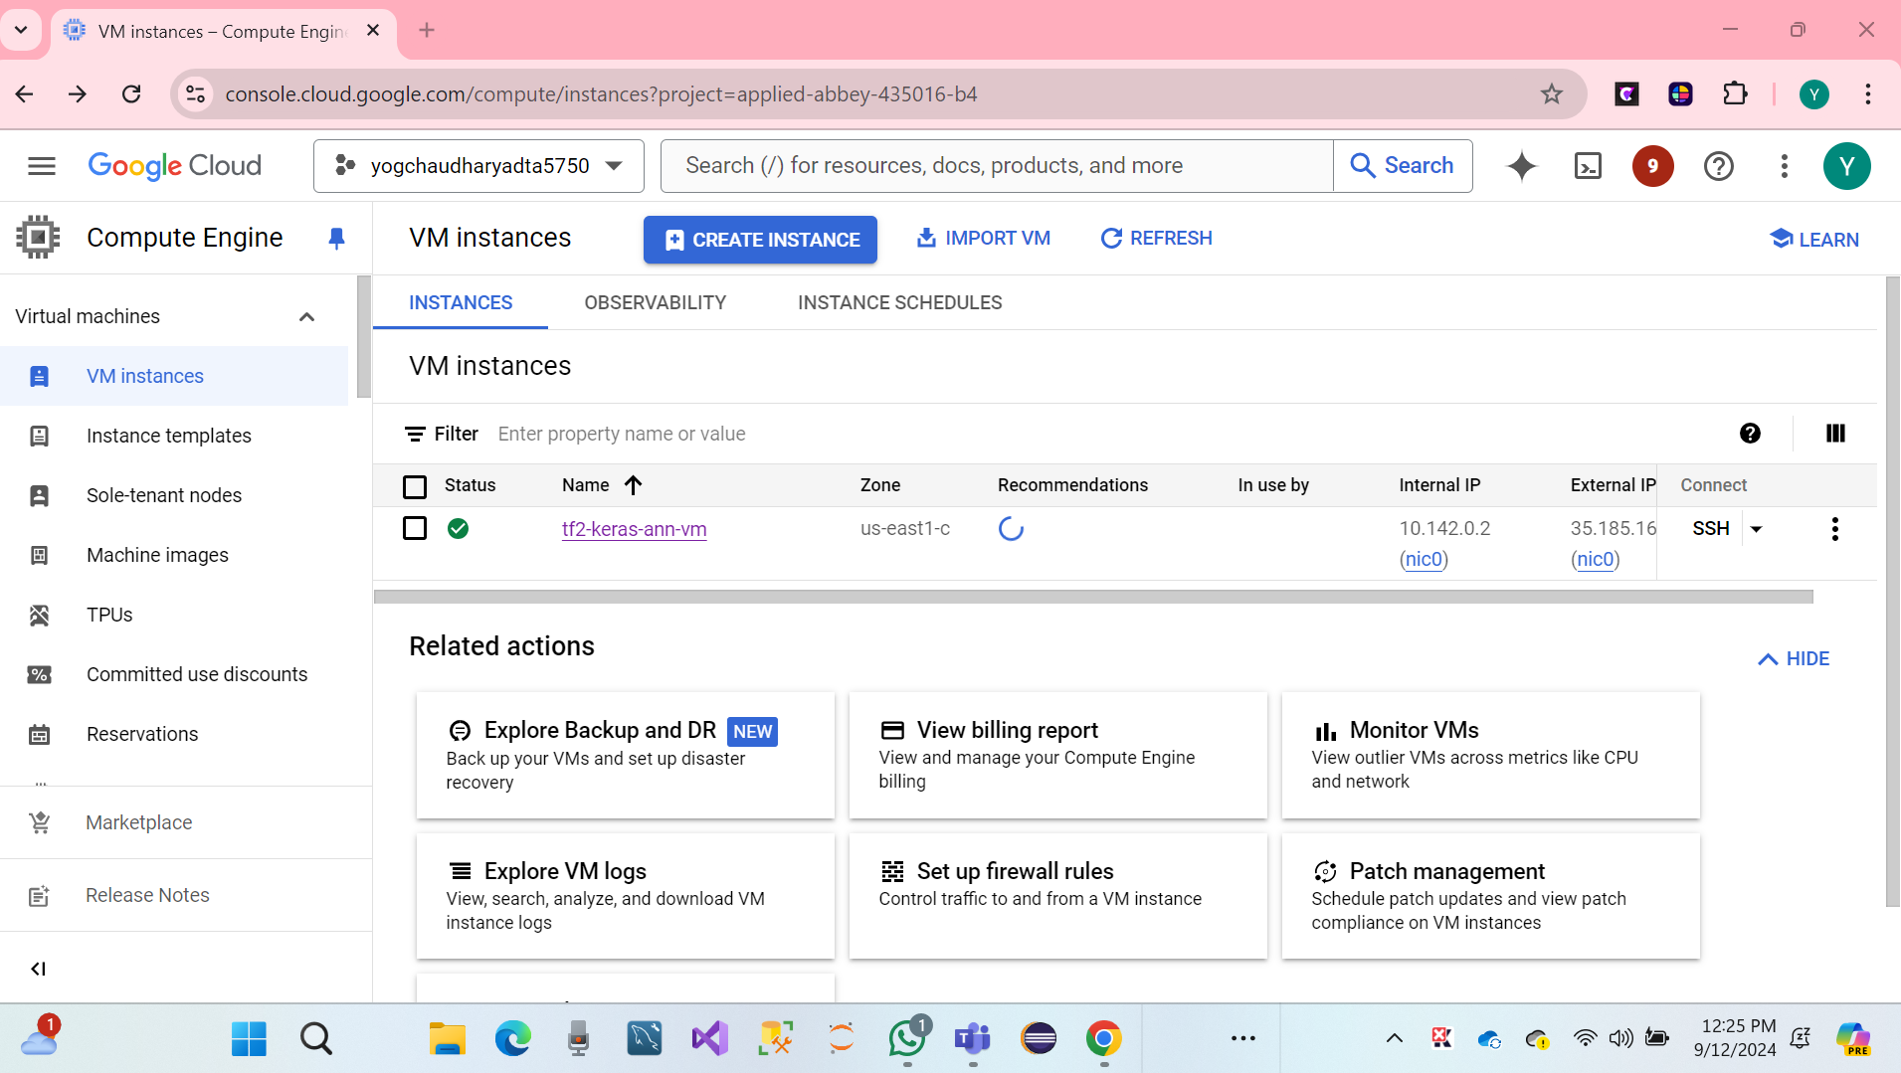

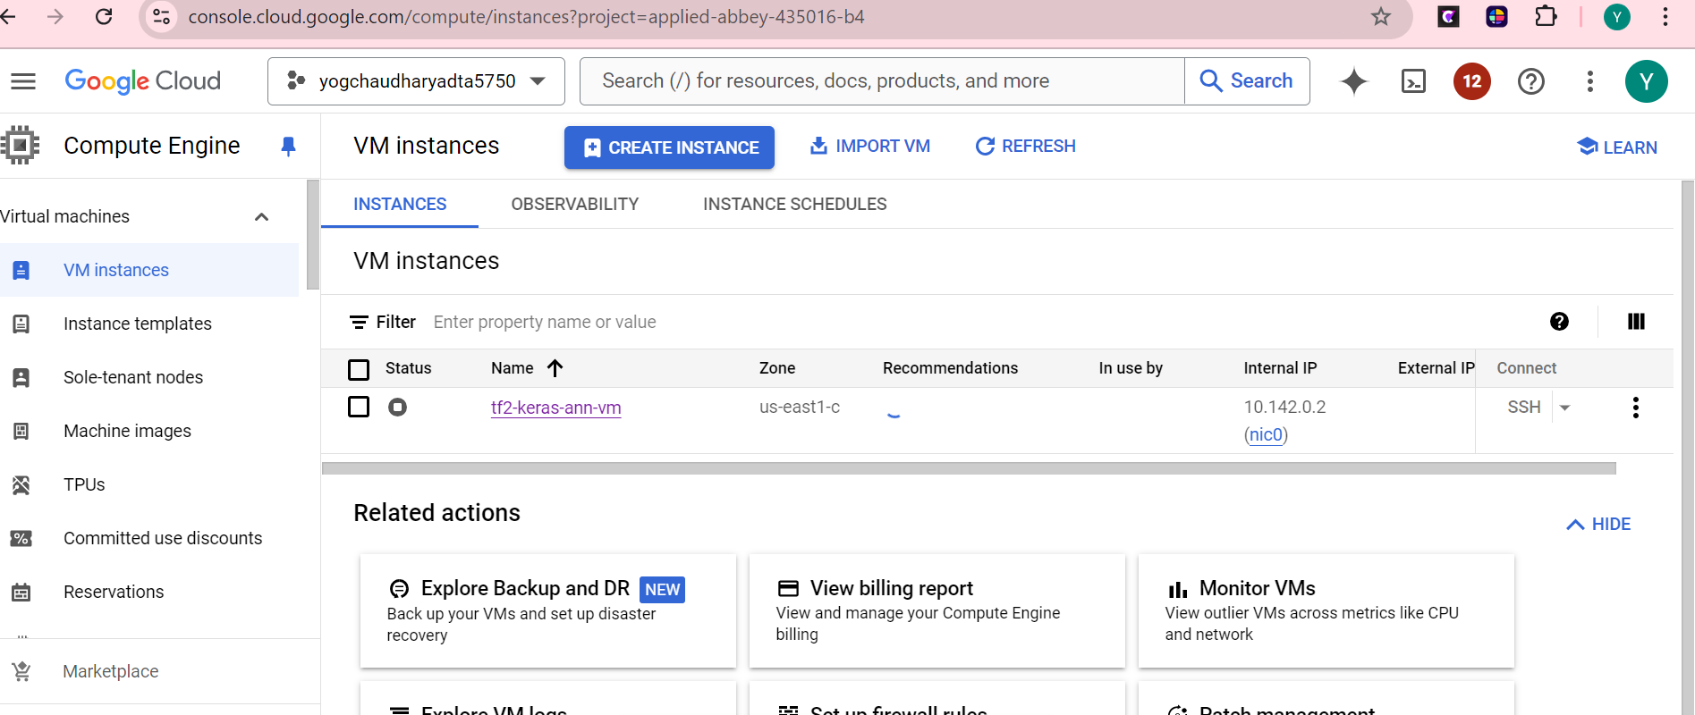

* We created the information page of the VM instances is Opened and Stopped.

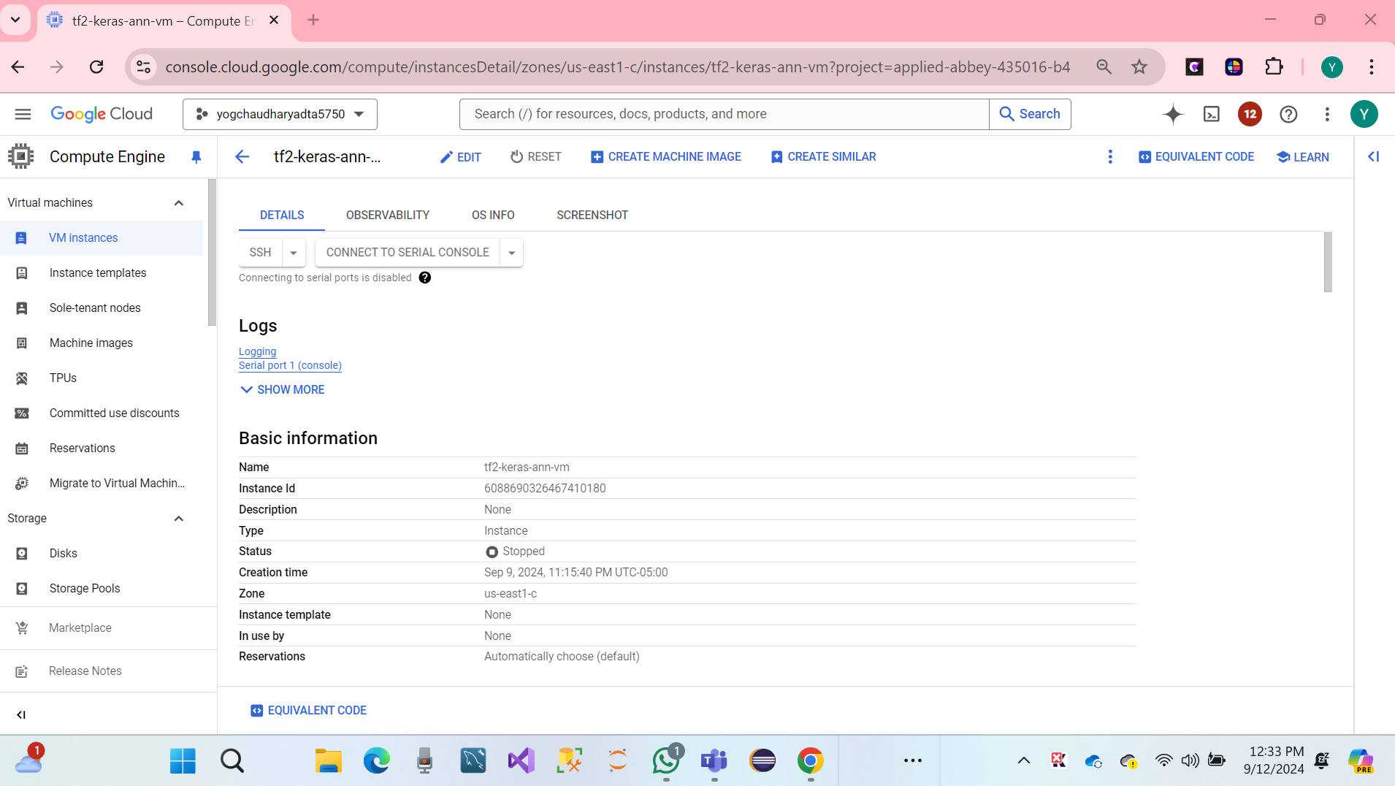

* Click to open edit on the top menu bar.

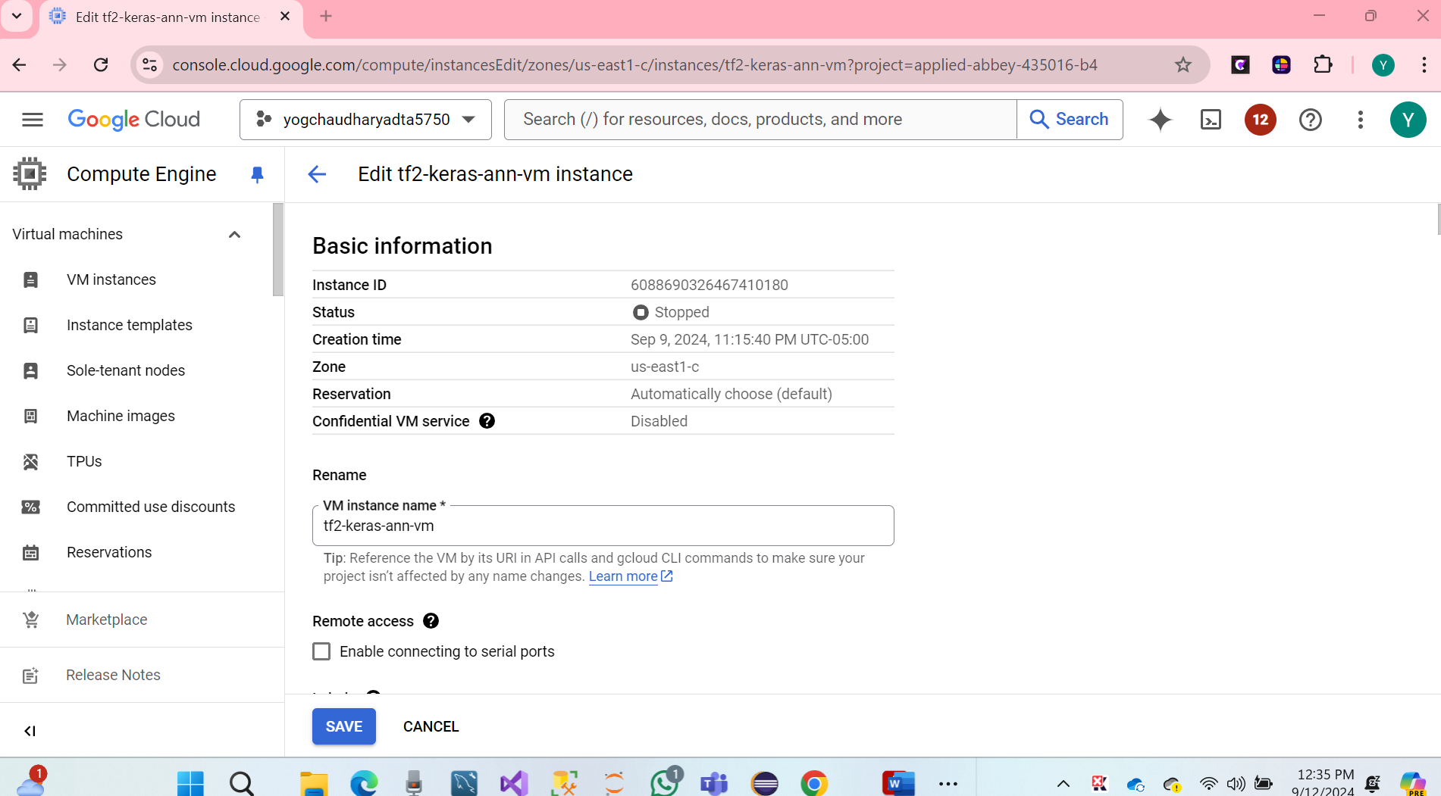

**Get credentials for the service account Open the IAM & Admin Service account page and open a drop-down menu.**

* Click on the open service account.

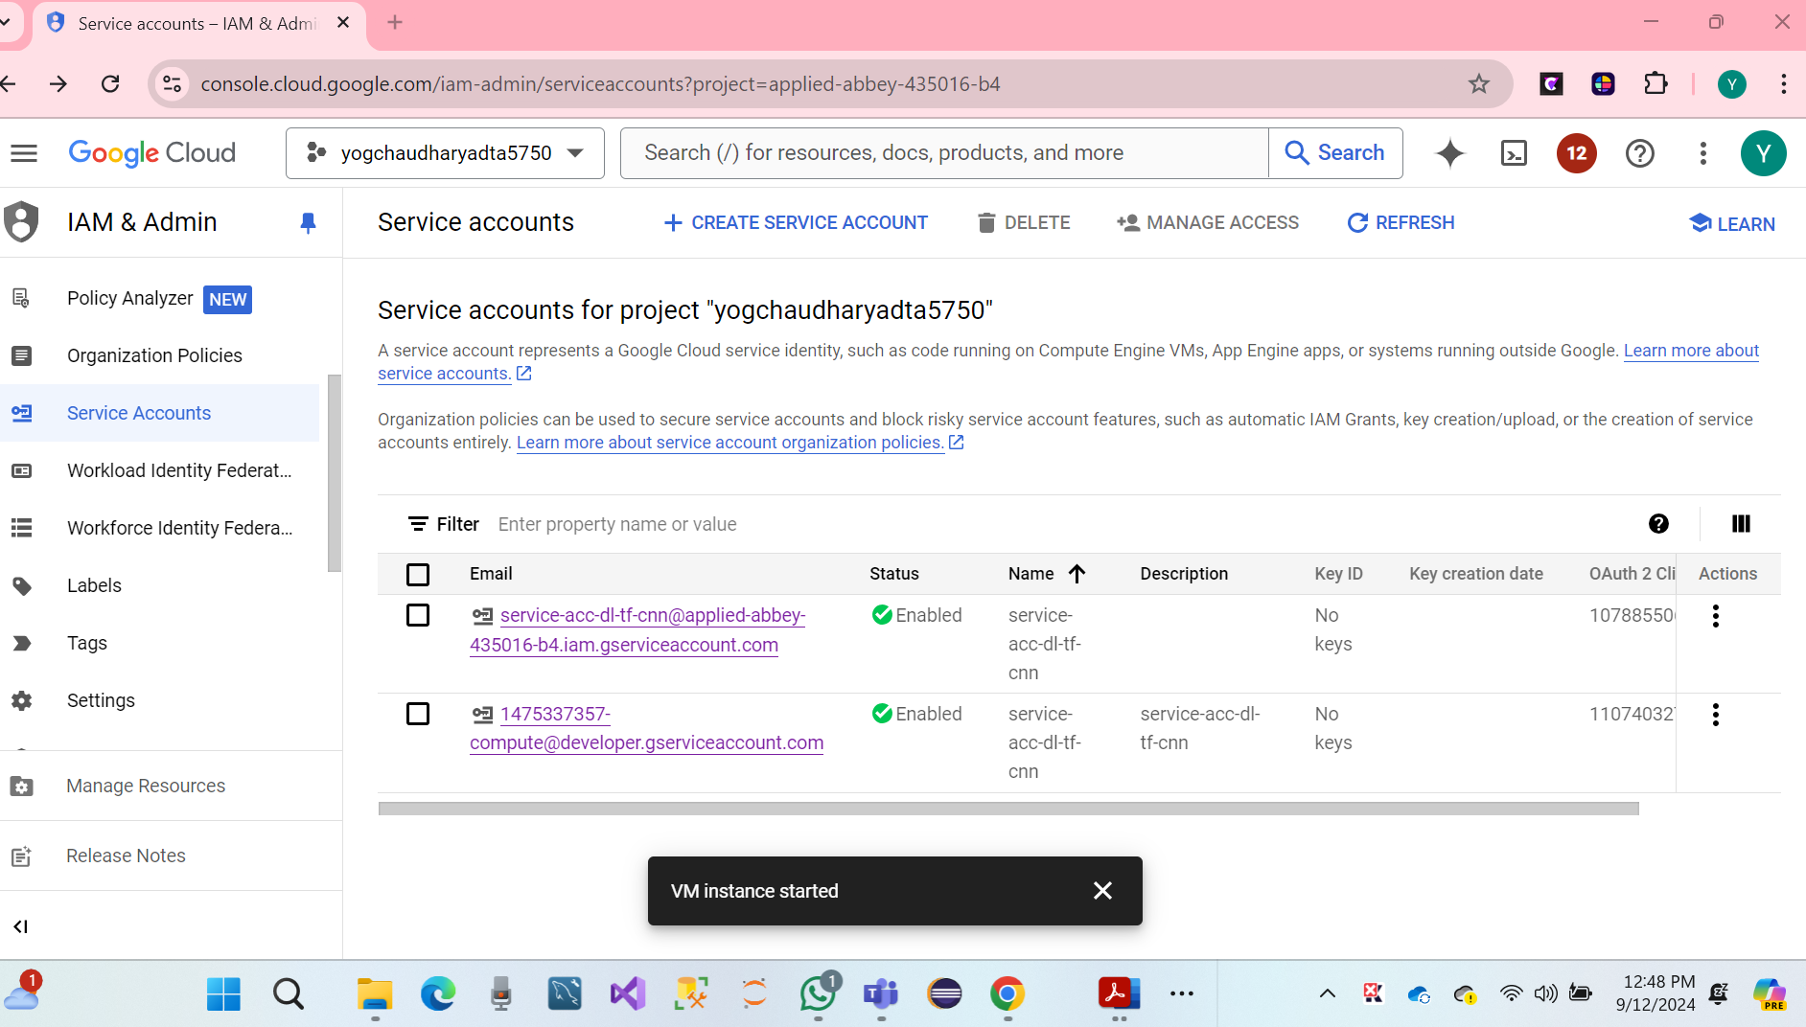

* **Copy email:** [**service-acc-dl-tf-cnn@applied-abbey-435016-b4.iam.gserviceaccount.com**](mailto:service-acc-dl-tf-cnn@applied-abbey-435016-b4.iam.gserviceaccount.com)

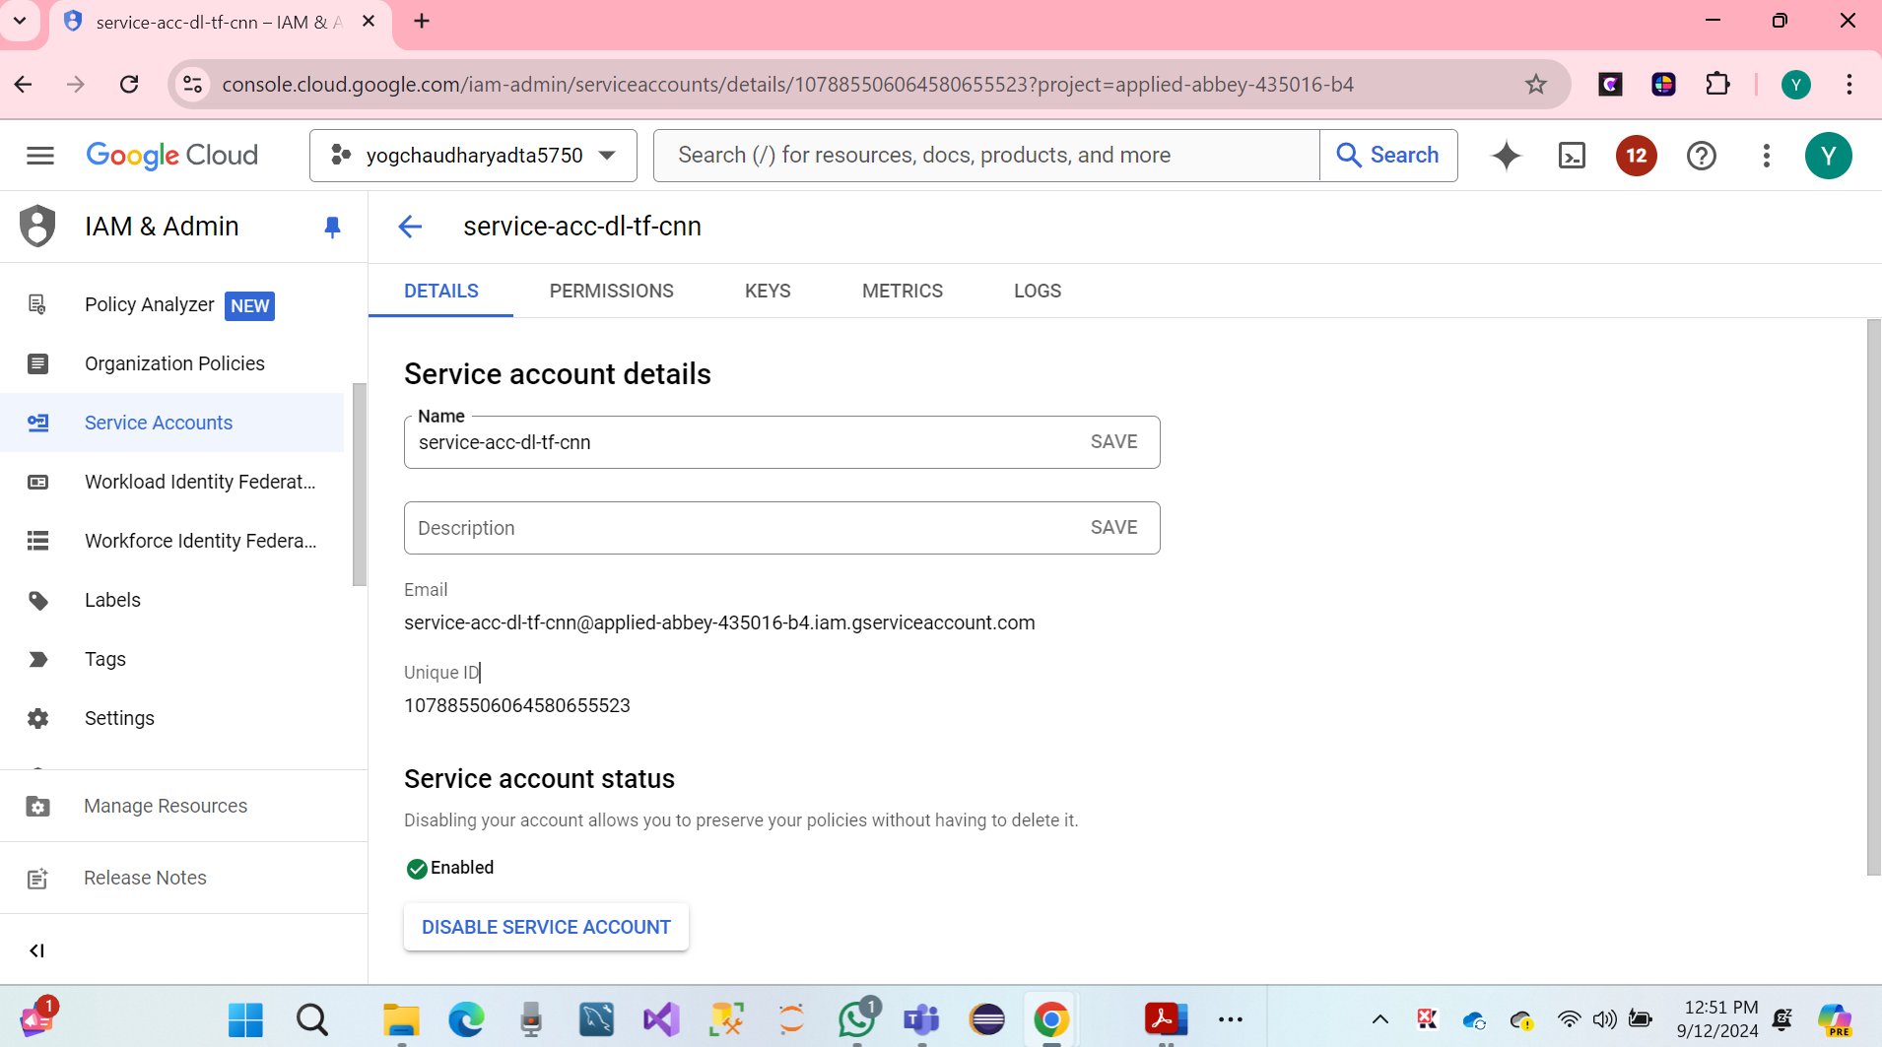

**We have a create Key file JSON of Service accounts.**

* Open an SSH connection to the remote deep-learning server
* Run Command below line
* Ls -all

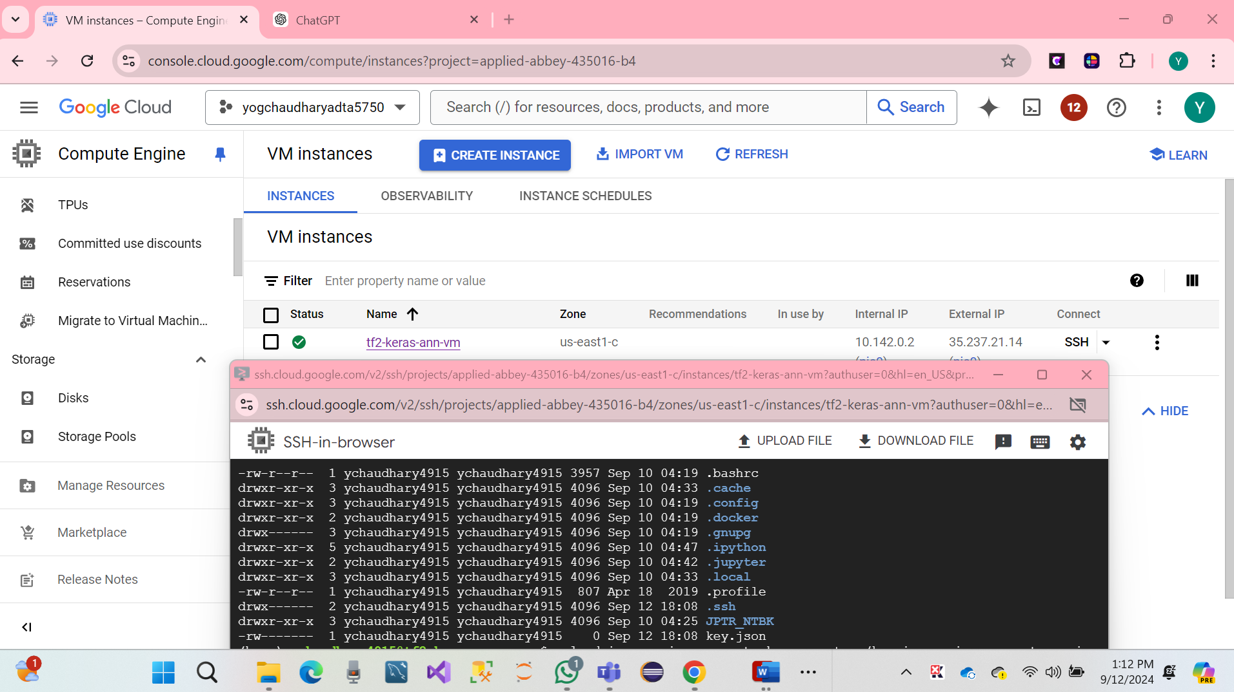

* We have created key.Json files found in the VM Instances home directory.

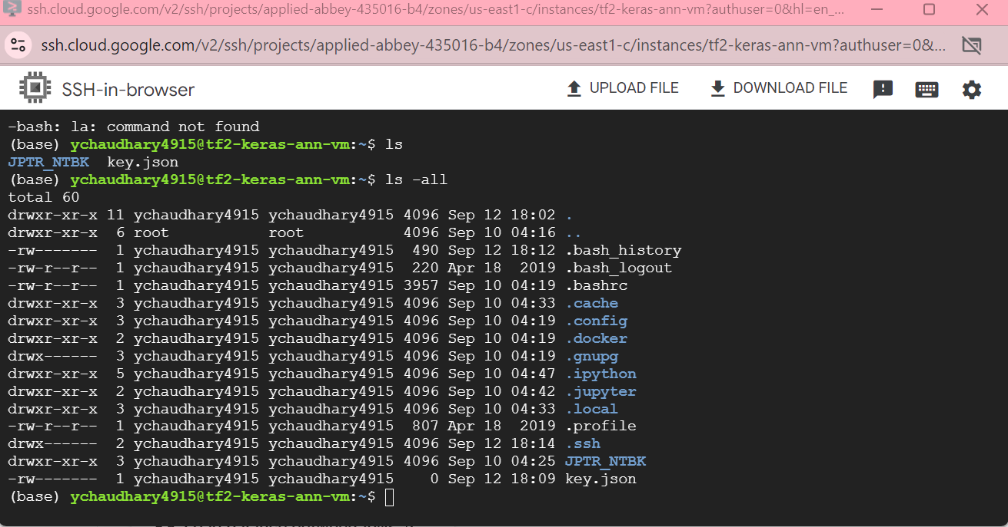

* Run Command below line.

gcloud iam service-accounts keys create ~/key.json --iam-account service-acc-dl-tf-cnn@applied-abbey-435016-b4.iam.gserviceaccount.com

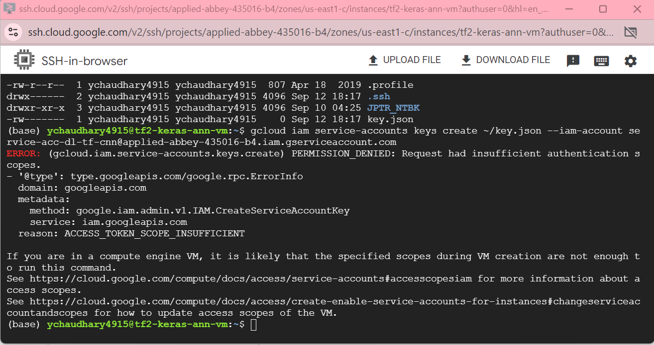

**finally, it’s done, gcp natural language api has been successfully set up.**

**9. PART VII: Join a Group (10 Points)**

**Discussion**

* **Yog Chaudhary**
* **Azhan Saleem**
* **Alwin Prabu**

**10. HOWTO Submit**

The student must submit all the sections, i.e., submission requirements, in a Microsoft Word document sent to the instructor (**Thuan.Nguyen@unt.edu** ) as an attachment to a UNT email.

The subject of the email must be: “**ADTA 5750: Assignment 1 – Submission**.”